____.____.20____
LESSON # 1
THE MICROSCOPE, ITS DEVICE AND RULES FOR WORKING WITH IT. PRO-AND EUKARYOTIC CELLS
Task # 1
Magnifying devices: preparation magnifier, microscope, their structure
The microscope, its structure
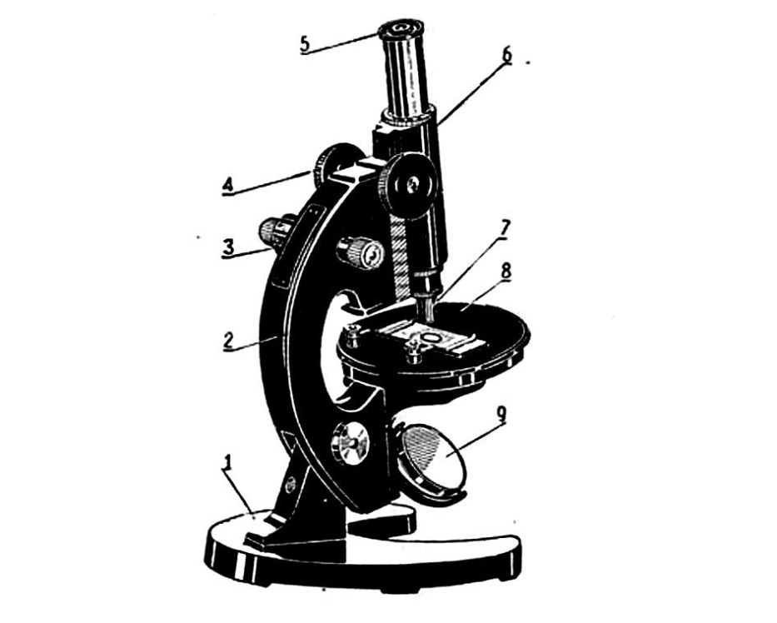
1. _______________________________
2. _______________________________
3._______________________________
4. _______________________________
5. _______________________________
6. _______________________________
7._______________________________
8 _______________________________
9. _______________________________

Task # 2
Rules for working with magnifying devices
RULES FOR WORKING WITH A MICROSCOPE
1. ____________________________________________________________________________
2. ___________________________________________________________________________
3. ___________________________________________________________________________
4. ___________________________________________________________________________
5. ____________________________________________________________________________
6. ____________________________________________________________________________
7. ____________________________________________________________________________
8. ___________________________________________________________________________
9. ____________________________________________________________________________ Signature ___________________
What is the IMPORTANCE of following the step-by-step implementation of actions when working with temporary and permanent micropreparations ____________________________
______________________________________________________________________________
_____________________________________________________________________________
List the possible causes of artefacts in the manufacture of preparations. Explain why you, as future doctors, need to distinguish artifacts when microscopy of micro-products____________. _____________________________________________________________________________
_____________________________________________________________________________
Task # 3
The cross of two hairs
Working with a permanent micro-product, to consolidate the skills of working with a microscope at different magnifications and mastering the rules for handling micro-products.

Small increase ___×___ Large increase ___×___
fig.1. __________________________ fig.2. ________________________
Task # 4
Cells of the integumentary tissue
Permanent preparations "onion Skin" and "Epithelium of the human oral mucosa" - study and draw at high magnification.
fig. 3. Preparation " onion Skin”
1. _______________________________
2. _______________________________
3._______________________________
4. _______________________________
5. _______________________________
Increase ___×___
Подпись ___________________

fig. 4 Preparation " Epithelium of the human oral mucosa”
1. _______________________________
2. _______________________________
3._______________________________
4. _______________________________
Increase ___×___
Specify the similarities and differences of tissue cells that perform a similar function in representatives of the plant and animal kingdoms.
Similarities: _____________________________________________________________________ ____________________________________________________________________________________ ____________________________________________________________________________________
Differences: ______________________________________________________________________ ____________________________________________________________________________________ ____________________________________________________________________________________
Task # 5
Blood cell
Permanent preparations "frog blood Cells" and "human blood Cells".
Study and draw the shaped elements of blood-red blood cells in frogs and humans at high magnification.

Increase ___×___ Increase ___×___
fig. 5 а. ___________________________ fig. 5 б. _________________________
1. _________________________ 1. _________________________
2. _________________________ 2. _________________________
3. _________________________ 3. _________________________
4. _________________________ 4. _________________________
Indicate the similarities and differences between the blood cells considered, representatives of cold-blooded animals - from the class Amphibians and warm-blooded-from the class Mammals.
Signature ___________________
Similarities: _________________________________________________________________________ ____________________________________________________________________________________ ____________________________________________________________________________________
Differences: _________________________________________________________________________ ____________________________________________________________________________________ ____________________________________________________________________________________
Task # 6
Variety of cells
Prokaryotic cells are bacterial cells. Eukaryotic cells are plant and animal cells.
fig. 6. The preparation is "a Bacterial cell. Colonies of bacterial cells”
1. _______________________________
2. _______________________________
3._______________________________
4. _______________________________
Increase ___×___
Structure of a PROKARYOTIC CELL (diagram)
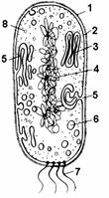
1. _______________________________
2. _______________________________
3._______________________________
4. _______________________________
5. _______________________________
6. _______________________________
7._______________________________
8 _______________________________

CELL ________________________________________________________________________________ _____________________________________________________________________________________
Signature ___________________

CELL THEORY (1838-1839) - main provisions
1. ___________________________________________________________________________________
2. ___________________________________________________________________________________
3.___________________________________________________________________________________
4. ___________________________________________________________________________________
Авторы: ______________________________________________________________________________
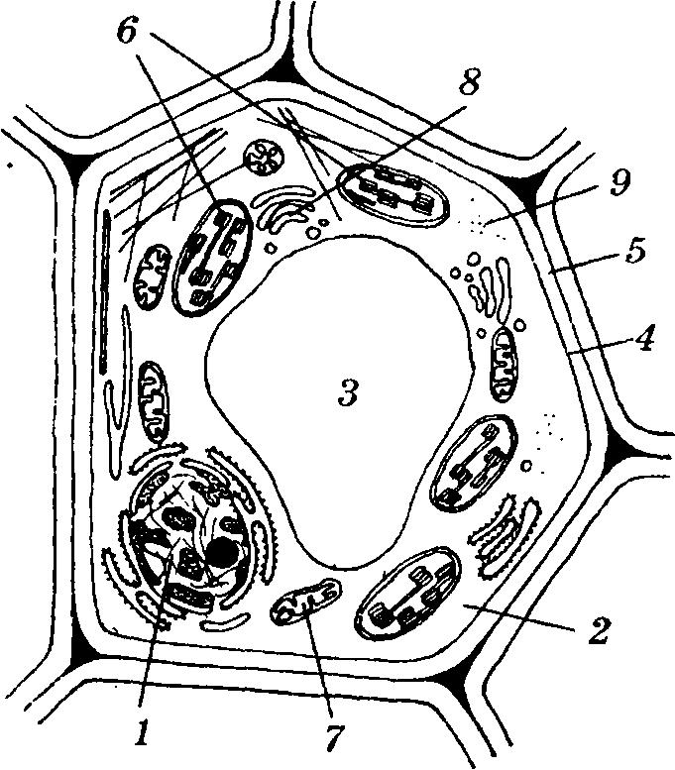
Structure of a PLANT CELL (diagram)
1. _______________________________
2. _______________________________
3._______________________________
4. _______________________________
5. _______________________________
6. _______________________________
7._______________________________
8 _______________________________
9. _______________________________

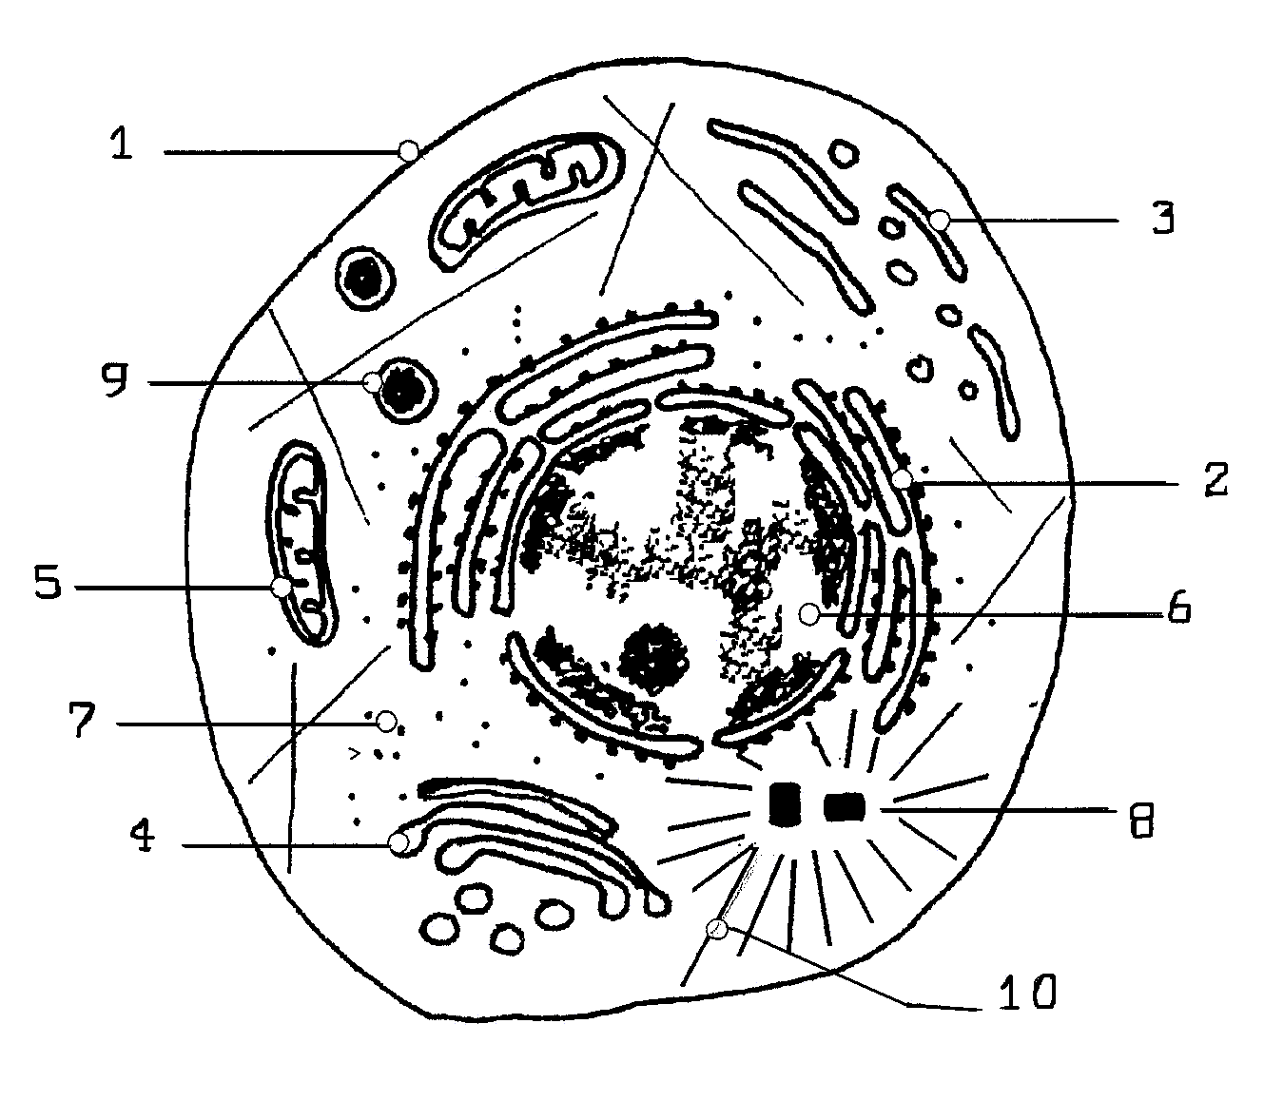
Structure of an animal cell (diagram)
1. _______________________________
2. _______________________________
3._______________________________
4. _______________________________
5. _______________________________
6. _______________________________
7._______________________________
8 _______________________________
9. _______________________________
10. _______________________________
Signature ___________________
What is the homology of plant and animal eukaryotic cells? _____________________________
____________________________________________________________________________________
____________________________________________________________________________________
Table CYTOLOGICAL FEATURES CHARACTERISTIC of PRO-and EUKARYOTES
№ | Signs | Of Prokaryotes | Of Eukaryotes
1 | Morphologically formed and separated from the cytoplasm by the nuclear envelope of the nucleus.
2 | Number of chromosomes
3 | Chromosomes are circular
4 | Chromosomes are linear
5 | The constant sedimentation of ribosomes
6 | Ribosome localization:
7 | - dispersed in the cytoplasm
8 | - attached to the endoplasmic reticulum
9 | Golgi apparatus
10 | Gas vacuoles not surrounded
11 | by A mitochondrial membrane
12 | Plastids (in phototrophs)
13 | Peroxisome
14 | Mesosome
15 | The system of microtubules
16 | Flagella (if present):
17 | - diameter
18 | - in diameter, they have a characteristic arrangement of microtubules "9+2»
19 | The membranes contain:
20 | - branched and cyclopropane fatty acids
21 | -polyunsaturated fatty acids and sterols
22 | The cell walls contain:
23 | - peptidoglycan (murein, pseudomurein)
24 | - teichoic acids
What are the main differences between Pro - and eukaryotic cells: a-by structure; b - by microscopy?______________________________________________________________________________________________________________________________________________________________________________________________________________________________________________________________________________________________________________
Signature ___________________

