Please answer the following questions in writing in your notebooks and attach a photo of the answer (put all photos in one file and attach to the assignment: you can collect all the files in a blank MS Word document without borders, put all the photos in sequential order; rotate the images for ease of reading, if it is necessary so that there are no images "sideways") and attach the file either in this format, or resave it in pdf.

- What is hormone?

- Classes of hormones

Fill in the table:
Chemical nature of hormones | Proteins and polipeptides | Lipid-derived hormones | Derivaties of aminoacids
Synthesis
Storage
Solubility (water or non-polar soluble)
Receptors
(membrane or nuclear)
Effects (fast or longer)
Examples

- Regulation of hormone production
Using this diagram, explain how the synthesis and secretion of hormones is regulated. What is negative feedback loop?
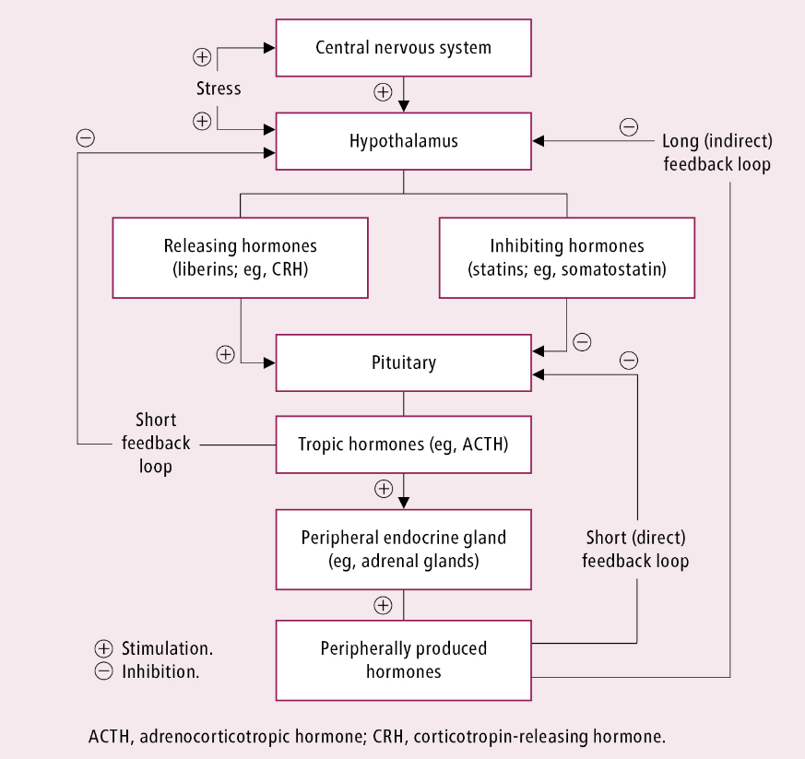

- Mechanism of action of hormones
What are the three steps of hormone signaling pathway? What are types of receptors?

- Mechanism of interaction of hormones with intracellular receptors in target cells.
Draw diagrams of these receptors action and describe them in your own words.
Which hormones act on nuclear receptor?

- Mechanism of interaction of hormones with cell-surface receptors in target cells.
- How does the enzyme-linked receptor work?
Draw diagrams of these receptors action and describe them in your own words.
Which hormones act on this receptor?

- What are the first messengers? What are the second messengers?
Draw diagrams of adenylyl cyclase–cAMP second messenger system and describe them in your own words.
Which hormones act on this receptor?

Draw diagrams of cell membrane phospholipid second messenger system and describe them in your own words.
Which hormones act on this receptor?

- Situational task
Glucocorticoids are used for the treatment of many diseases. Why abrupt withdrawal of glucocorticosteroid medications is dangerous after a prolonged course of treatment?
(The diagram from the question 3 can help answer)

