[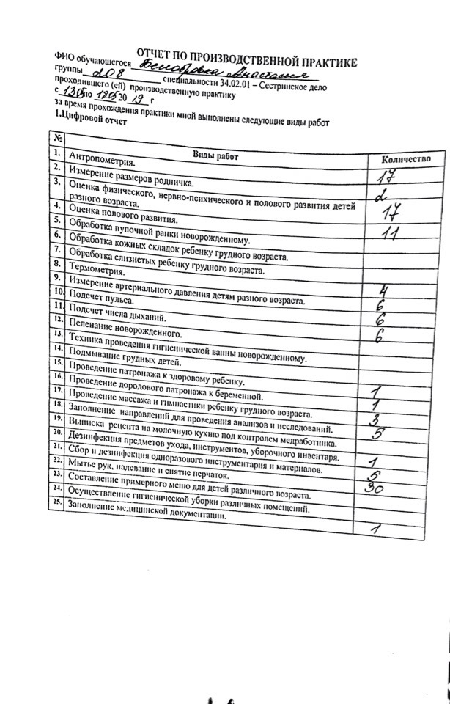](https://vk.com/photo439715471_456257493)