[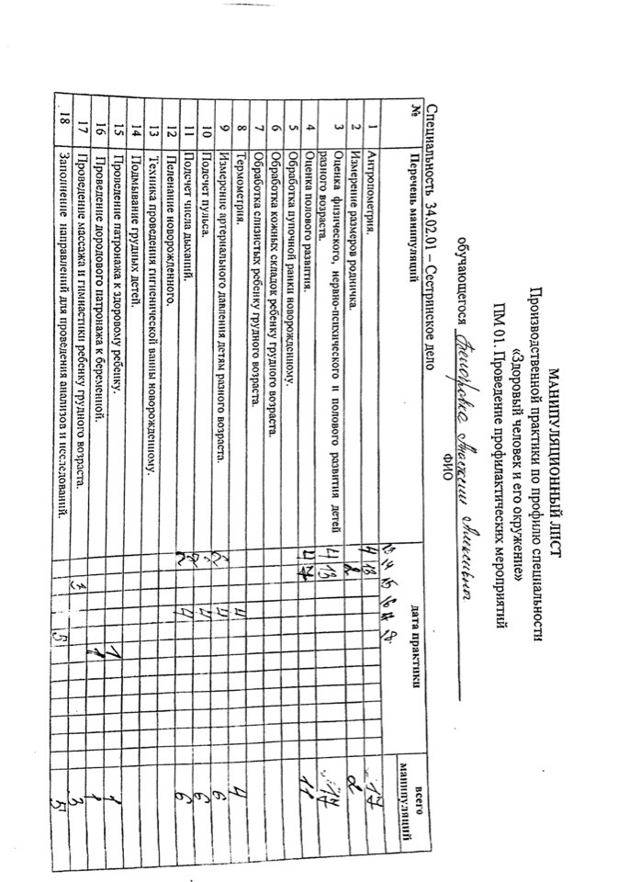](https://vk.com/photo439715471_456257487)[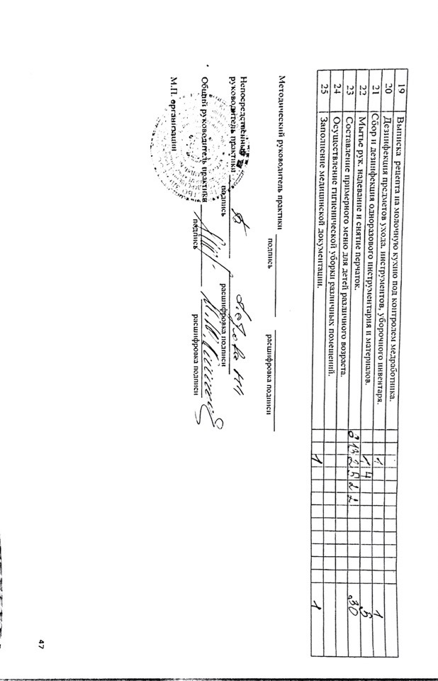](https://vk.com/photo439715471_456257489)