Plasma proteins
- Blood composition
- What is a centrifuge used for in a laboratory?
The picture below shows the result of blood centrifugation.
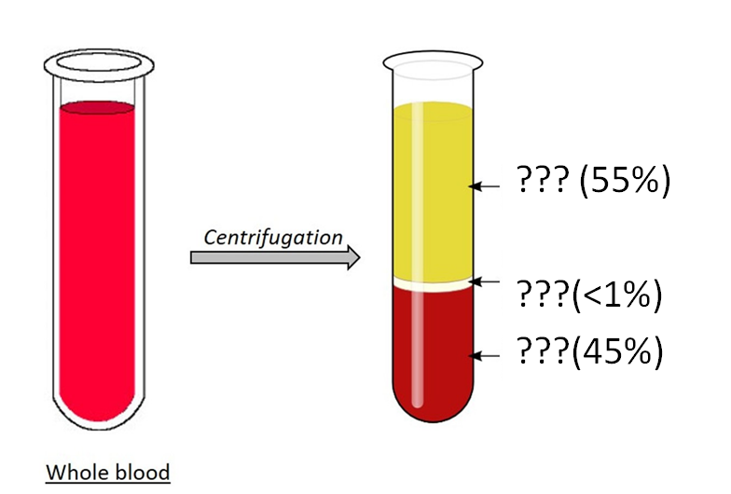
- How many layers are formed when blood sample is centrifuged? Name these layers.
- What blood cells are found in the buffy coat of centrifuged blood?
- What is hematocrit? What percent of blood is hematocrit?
- What is difference between blood and plasma? What is difference between plasma and serum?

- Plasma components
- What are the components of plasma?
- What are 3 types of plasma proteins? How blood plasma proteins are separated into three groups?
- Which organ produces most of the plasma proteins? Which plasma protein is not synthesized in the liver?
- What other components does plasma contain besides water and proteins? List these components. Why are they covered in blood?

- Blood proteins
- Briefly (2-3 sentences about each protein) describe the properties and functions of the following plasma proteins: albumin, gamma globulin, high-density lipoproteins (HDL), low-density lipoproteins (LDL), hemoglobin, transferrin, haptoglobin, ceruloplasmin, fibrinogen, plasmin, thrombin, renin, alpha-1 antitrypsin, C-reactive protein.
- Which of these proteins belong to the alpha globulins? Which of these proteins belong to the beta globulins?
- What protein hormones are in the blood? Why they can be found in the blood?
- What are the acute phase proteins? What are examples of acute phase proteins?
- Match these proteins in the table with their function:
albumin, gamma globulin, HDL, LDL, hemoglobin, transferrin, haptoglobin, ceruloplasmin, fibrinogen, plasmin, thrombin, renin, alpha-1 antitrypsin, C-reactive protein, insulin, cytokines, antithrombin, glucagon.
Function | Transport | Osmotic pressure | Enzyme | Enzyme inhibitor | Regulatory function | Immune function | Clotting factors | Fibrinolysis
Proteins

- Pathology
- What are normal blood protein levels?
- What is hyperproteinemia? What causes high blood protein? What are the symptoms of high protein in blood?
- What is hypoproteinemia? What causes low blood protein? What are the symptoms of deficiency protein in blood?
- What is paraproteinemia?
- What is the dysgammaglobulinemia? What is the Agammaglobulinemia? What happens if immunoglobulins are low?

Hemoglobin. Heme metabolism. Jaundice.

- Hemoproteins
- What is chromoprotein?
- What is hemoprotein structure?
- What is heme? Where is heme found?
- What is heme structure? What is porphyrin?
- Name the selected elements in the picture below.
1 –
2 –
3 –
4 –
5 –

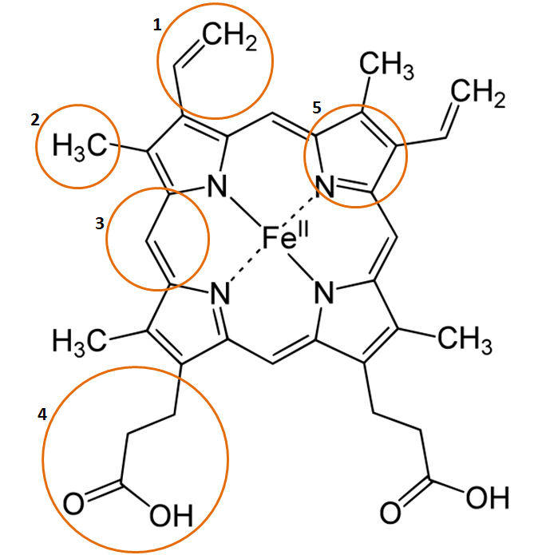

- How many bonds can iron form in heme? With which atoms is iron coordinated in heme?
- What are hemoprotein examples? Where are they found in humans? What functions are performed by hemoproteins?

- Hemoglobin
- Name the numbered items in the picture below.
1 –
2 –
3 –
4 –
5 –
6 –

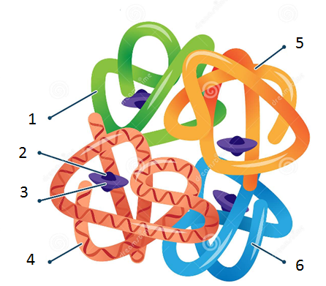

- What are the parts of hemoglobin?
- How many protein subunits are in hemoglobin?
- How many oxygen can one hemoglobin carry?
- What is normal hemoglobin? What is abnormal hemoglobin? What disease causes abnormal hemoglobin?

- Describe the forms of hemoglobin:
Form | What binds to the hemoglobin? | Where this molecule is binds to the hemoglobin? | Function
Deoxyhemoglobin
Oxyhemoglobin
Carbaminohemoglobin
Carboxyhemoglobin

- Can carboxyhemoglobin lead to death?
- What does methemoglobin mean? What is the difference between hemoglobin and methemoglobin? How does methemoglobin affect the blood? Why is methemoglobin bad to organism?

- Hemoglobin synthesis
- Where the protein part is synthesized? Where the heme part is synthesized?
- Which nutrients are required for heme synthesis? Where does heme synthesis begin? How is heme formed?

- Heme catabolism
- Complete the scheme of heme catabolism.
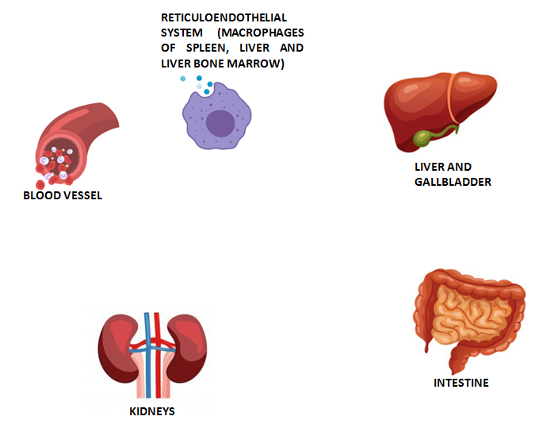
- How many days do erythrocytes live? What happens to erythrocytes after? What organ destroys old red blood cells?
- What happens to the protein part of hemoglobin?
- What happens to the iron that is released during the breakdown of damaged red blood cells?
- What enzyme converts unconjugated bilirubin?

- Describe the two types of bilirubin:

Type of bilirubin
Where is this type formed?
Bonded to glucuronic acid (yes/no)
Solubility in water (yes/no)
Have direct reaction with Ehrlich's reagent (yes/no)
Pass through membranes (yes/no)
Excreted by kidneys (yes/no)
Toxic (yes/no)

- Pathology
- Fill the tables:
Jaundice type | Violation of heme catabolism | Causes
Prehepatic/hemolytic
Hepatic/hepatocellular
Posthepatic/cholestatic

 | Normal level | Prehepatic jaundice | Hepatic jaundice | Posthepatic jaundice
Total serum bilirubin
Conjugated bilirubin
Unconjugated bilirubin
Alanine transferase and aspartate transferase levels
Urobilinogen
Urine color
Stool color
Conjugated bilirubin in urine

