The Nervous System
- Watch video and write down words related to the theme “Nervous System”
Reading Task:
2. Make a list of questions (5-7) to ask a lecturer of Anatomy.
3. Translate the text in written form.
First variant Нечетный номер в списке
This part of the brain is responsible for our thoughts, emotions, perceptions and other behaviours, and is the most recently developed (the youngest part of your brain – in terms of evolution – is the front part). You can see this and other CNS structures in figure.
The cortex is also known as the cerebrum; there is another structure at the back and slightly underneath the brain which looks like a little brain, called the cerebellum. This is involved in posture and maintaining balance, amongst other things.
Second variant Четный номер в списке
From the back of the brain extend the pons and medulla oblongata, or brain stem. The brain’s cranial nerves originate here – there are twelve of these conveying information about the senses and muscles to the rest of the brain. The trigeminal nerve, the largest, responds to chemical stimulation: crying to a peeling onion or the whack of the smell of ammonia is due to stimulation of the trigeminus. Behaviours such as chewing are allowed because the command to chew is communicated via a cranial nerve. Speech muscles, eye muscles and tongue movement are also controlled by the cranial nerves.

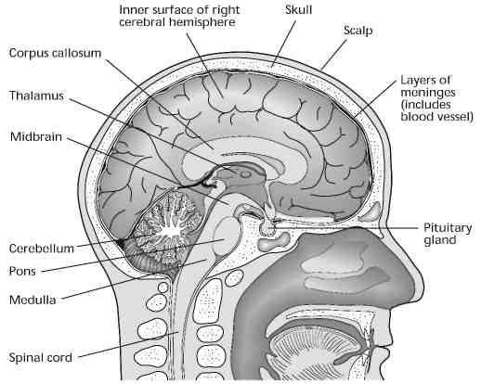

Vocabulary exercises

1. Find in the text English equivalents of the following words.

Ответственный, мышление, эмоции, восприятие, поведение, структура, мозжечок, костный мозг, прдолговатый мозг, тройничный нерв

2. Complete the text using the words below. Use each word only once.
wiring, components, brain, neurons, control, spinal cord, back, skull

The nervous system is the 1) ----- of the body. The nervous system has two 2) ----- .The central nervous system consists of the 3) ----- and spinal cord. The brain is the 4) ----- and processing centre of the system. Like any organ, the nervous system is made up of billions of cells, called 5) -----, that perform the main functions of the brain. The brain and 6) ----- are as soft as gelatin, and quite vulnerable. The brain is ultimately protected by the bones of the 7) -----, while the spinal cord is protected by the bones of the 8) ----- (vertebrae).

Follow - Up Activities

Be ready to speak about the nervous system using new vocabulary.

