At a Conference with International Participation
Prof. V.F.Voino-Yasenetsky Krasnoyarsk State Medical University is one of the world-known educational institutions. It rates among the best medical universities in the country. From time to time it hosts international conferences and congresses. Some years ago it hosted an international conference “Modern Medical Education: Traditions and Innovations”. On the agenda there was the plenary meeting, some reports were made by leading specialists in the field of medical education, and some time was reserved for discussions and master classes. Rector of KrasGMU spoke out with a welcoming address. The participants of the Conference were greeted by the director of the Department of Science, Education and Manpower Policy of the Ministry of Health Service and Social Development of the Russian Federation, and Minister of Health Service of the Krasnoyarsk territory.
Stefan Lindgren, WFME* President, made a report “Assessment of Quality of Students at Medical Schools”. There were three main items in his report: Professional competence, Assessment of competence, and Standards for development and accreditation of educational programmes. Mr. S. Lindgren began his report by saying that doctors as clinical scientists apply the principles and procedures of medicine to prevent, diagnose, care for and treat patients with illness, disease and injury and to maintain physical and mental health. They supervise the implementation of care and treatment plans by others in the health care team and conduct medical education and research. He spoke about the global role of the doctor in health care, what the doctor is able to do, and what they should do. Mr. Lindgren enumerated the core competences of a doctor:
- Patient care
- Communication skills
- Technical skills
- Professional, ethical and legal issues
- Organizational planning and service
- Management skills
- Academic activities – education and research
Both days of the conference were filled with reports, scientific communication and all kinds of consultations. The conference ended with the concluding remarks made by Rector of KrasGMU. The conference proceedings were published in the Collection of reports.
Stefan Lindgren suggested a scheme of professional competence. At first a specialist gets knowledge (he knows), then his knowledge gets wider (he knows how), then he can show how to perform some manipulations and at last he can do his work independently!

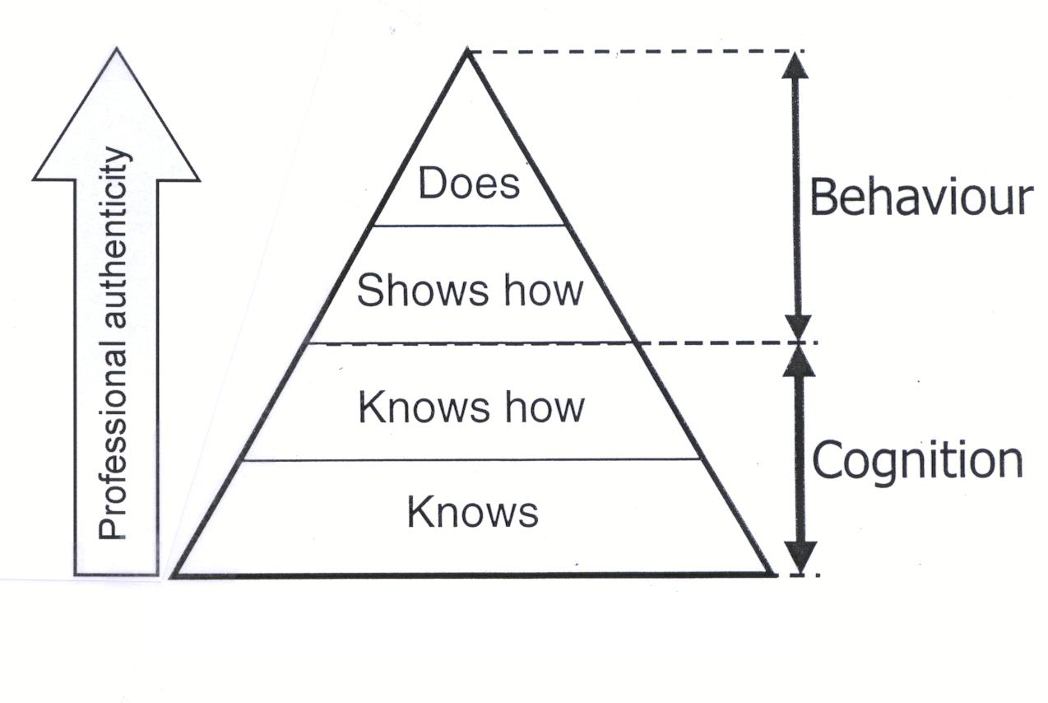
*WFME – World Federation for Medical Education – Всемирная Федерация медицинского образования (была образована в 1984 году).
1.Выпишите из текста следующие словосочетания:
- проводить международные конференции -
- на повестке дня -
- выступить с приветственным словом –
- департамент науки, образования и кадровой политики –
- поддерживать физическое и психическое здоровье –
- основные компетенции врача –
- заключительное слово –
- сборник докладов –
- выполнять свою работу самостоятельно –
2.Переведите основные компетенции врача, которые перечисляет Стефан Линдгрен:
1.
2.
3.
4.
5.
6.
7.
3. Представьте, что вы приняли участие в конференции. Поделитесь своими впечатлениями, используя следующие слова и словосочетания:
host the conference, devote to …, conference participants, international participation, prominent scientists, open a discussion, agenda, modern approaches to…, give the floor to …, share experience in …, learn about achievements, watch some surgeries online, exchange of opinions, strengthening of cooperation, useful.

