Тема №11. The oral cavity. The Structure of a Tooth.

- Read the text and answer the questions after it.

The Oral Cavity

The human oral cavity refers to the mouth, and all its parts including the lips,
tongue, teeth, and the roof and floor of the mouth. Primarily belonging to the
digestive system, the oral cavity also plays an important role in respiration.
The oral cavity is the anatomic space that forms the outer limit of the alimentary canal. It consists of the lips anteriorly, the oral vestibule, the palate, and the teeth. The distal end is made up of the pharynx.
The oral fissure (rima oris) is the beginning of the oral cavity. The isthmus of the fauces (isthmus faucium) is the posterior edge formed by an anterior and a posterior pharyngeal arch (palatoglossal and palatopharyngeal arches).
The area between the cheeks and the teeth is referred to as the oral vestibule (or vestibulum oris). The oral cavity proper is limited by the rows of teeth at the back.
The hard and soft palate form the roof. The cheeks form the lateral walls of the cavity. The orbicularis oris muscle runs around the mouth like a ring and forms, together with the buccinator muscle (a chewing muscle), the cheek and mouth musculature.

Teeth
Normally, an adult has 32 teeth, 16 in each jaw. They are divided into four quadrants with eight teeth each: two incisors (dentes incisivi), one canine (dens caninus), two premolars (dentes premolares), and three molars (dentes molares) make up one quadrant.
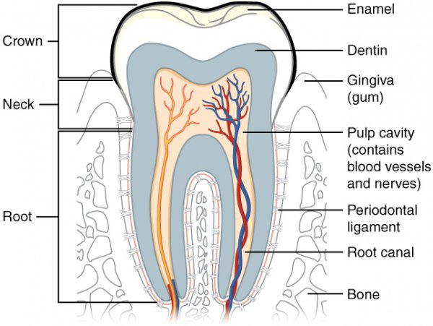
Each tooth is located in an alveolar process and is held in position by the periodontal ligament. The teeth consist of enamel (enamelum), dentine (dentinum), and dental cement (cementum).
Note: Dental enamel is the hardest substance in the human body.
The Structure of a Tooth.

Every tooth consists of a crown, a neck and one or more roots. The crown is the part visible in the mouth and the root is the part hidden inside the jaw. The junction of crown and root is called the neck and the end of the root is called the apex. Every tooth is composed of enamel, dentine, cementum and pulp.
Enamel
This is the outer covering of the crown and is the hardest substance in the body. It is insensitive to pain. Unlike most other body tissues it cannot undergo repair; thus any damage caused by decay or injury is permanent. The microscope shows that it consists of long solid rods, called enamel prisms, cemented together by the interprismatic substance. The prisms run roughly at right angles to the surface.
Cementum
This is the outer covering of the root and is similar in structure to bone. Cementum meets enamel at the neck of the tooth.
Dentine
This occupies the interior of the crown and root, and is very sensitive to pain. Dentine from elephants' tusks is commonly known as ivory but is exactly the same dentine as that found in human teeth.
Pulp
Unlike enamel, dentine and cementum, the pulp is purely soft tissue. It contains blood vessels and nerves, and occupies the centre of the dentine. Vessels and nerves of the pulp enter the root apex through the apical foramen and pass up the root canal into the crown, where the space occupied by the pulp is called the pulp chamber. The nerves of the pulp are responsible for pain felt when dentine is drilled or toothache occurs. The outermost layer of the pulp, next to the dentine, is lined with the special cells which formed the dentine. Under the microscope fine prolongations of these cells can be seen passing through tubes in the dentine. They run throughout the full thickness of dentine and, by their origin from the pulp, are associated with its repair processes and sensitivity to pain.
Supporting Structures
Every tooth is inserted into the jaw by its root. The part of the jaw containing the teeth is known as the alveolar process' and is covered with a soft tissue called gum. The jaw bones consist of a dense outer layer known as compact bone and a softer interior called spongy bone.
A tooth is attached to its socket in the jaw by a soft fibrous tissue called the periodontal membrane. This acts as a shock absorber and is attached to the cementum of the root and the compact bone lining the socket. The periodontal membrane contains nerves and blood vessels, but consists mainly of bundles of fibres which pass obliquely from cementum to bone.

- What does an oral cavity consist of?
- Name three parts of a tooth.
- What part of a tooth is not visible in the mouth?
- How is the junction of crown and root called?
- What is every tooth composed of?
- What do you know about enamel?
- What does it consist of?
- Where does cementum meet enamel?
- What is cementum?
- Is dentine sensitive to pain?
- What does the pulp contain?
- What is the pulp chamber?
- Ask your own 3 questions to this part of the text:

Supporting Structures
Every tooth is inserted into the jaw by its root. The part of the jaw containing the teeth is known as the alveolar process and is covered with a soft tissue called gum. The jaw bones consist of a dense outer layer known as compact bone and a softer interior called spongy bone.
A tooth is attached to its socket in the jaw by a soft fibrous tissue called the periodontal membrane. This acts as a shock absorber and is attached to the cementum of the root and the compact bone lining the socket. The periodontal membrane contains nerves and blood vessels, but consists mainly of bundles of fibres which pass obliquely from cementum to bone.

