Lesson 2 – Enzymes

1. Property of inorganic catalysts and enzymes.
Fill in the table
Property | Inorganic catalysts | Enzymes
Chemical nature
Molecular weight
How they effect on activation energy
How they effect on the equilibrium of a reversible reaction
Will they change during the reaction?
Efficiency / reaction rate
Specificity
Optimum conditions (pH, temperature, pressure)
Are they regulated?

2. Enzyme structure.
Name the numbered structures of the enzyme.
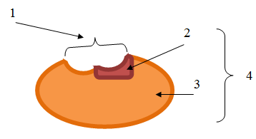
What is an active site of enzyme? What is a structure of active site?
What is a cofactor? What are the types of cofactor? What are some examples of these types?
What is the difference between a prosthetic group and a coenzyme?

3. Mechanism of the enzymatic reaction.
Describe what happens at each stage of an enzymatic reaction.
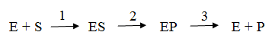
4. Optimum conditions for enzyme activity.
Explain the graphs. Why does the enzyme activity change?
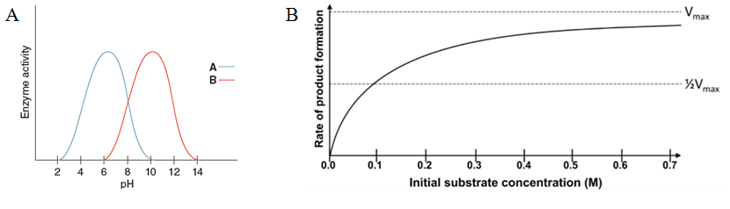
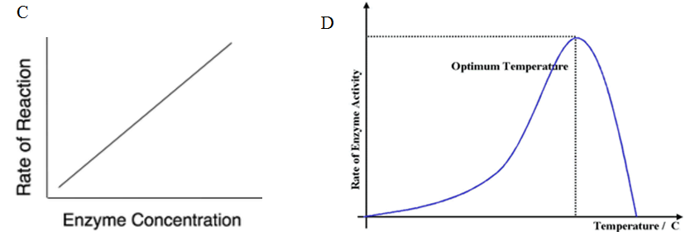

5. Enzyme classification.
What are the 6 classes of enzymes? What is the basis of classification of enzymes?
Name the classes of enzymes that catalyze the following reactions:
