Nucleic acid and protein synthesis

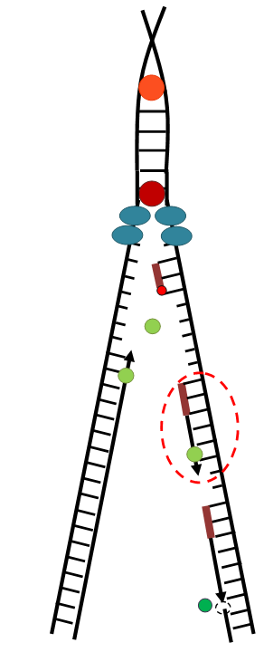
- What are RNA and DNA? What functions do they perform? Describe the structure of RNA and DNA.

- What is replication? When does replication occur? What is the significance of replication?
What are the stages of replication? Draw a replication fork. In the figure, indicate the direction of the DNA strands, the leading strand and the lagging strand, direction of DNA strands synthesis.

Fill in the table:
Symbol | Name of element / protein / enzyme | The function
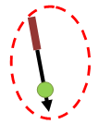

- What is DNA transcription? When does DNA transcription? What is the significance of transcription?
What are the similarities and differences between replication and transcription? What are the stages of DNA transcription? What substrates and enzymes are required for DNA transcription? Explain their role in this process. What is RNA processing?
4. What is translation? What are the stages of translation? What substrates and enzymes are required for DNA transcription? Explain their role in this process.
What is aminoacyl-tRNA? What is the significance of aminoacyl-tRNA?

- What is genetic code? What are its properties?

- How protein translation is regulated?

