Pharmacodynamics is a branch of Pharmacology that deals with pharmacological effects, mechanisms, sites and types of action of medicinal substances.
Pharmacological effects of MS are changes in the functions of the body?s organ system-sin response to the MS.
MS mechanisms of action are ways through which the substances exert pharmacological effects. The main molecular targets of medicinal substances are the following structures:
• receptors;
• enzymes;
• ion channels;
• transport systems. Receptors are functionally active macro-
molecules ensuring cellular response to the action of transmitters or other substances. Their binding to the receptor-specific affinity substances (ligands) causes conformational changes of receptor protein, and initiates a chain of cellular biochemical reactions leading to certain effects on tissues, organs, and systems (pharmacological effects, if the ligand is a medicinal agent). Receptors serve as targets for either endogenous ligands (neurotransmitters, hormones, cytokines and other endogenous biologically active substances), or exogenous biologically active substances (including drugs). There are four types of receptors (fig. 1.1):
• ligand-gated ion channels, also termed iono-tropic receptors (see fig. 1.1, а);
• G-protein coupled receptors, also termed metabotropic receptors (see fig. 1.1, b);
• Enzyme-linked receptors (e.g. tyrosine ki-nase) (see fig. 1.1, c);
• Intracellular receptors (receptors regulating transcription of genes) (see fig. 1.1, d).
А. Ion channel coupled receptors. After binding of an agonist or an antagonist to an ion channel receptor, the transmembrane conductance of specific ions increases or decreases within milliseconds, causing a change in the cell membrane electrical potential. Vital activity of the cell strongly depends on Na⁺, К⁺, Cа²⁺, Cl⁻, and H⁺ ions. Passage of ions through channels is affected by many antiarrhythmic drugs [Procainamide (Novocainamide♠), Amiodaron, and others)], local anesthetics [Procaine (Novocain♠), Lidocaine], anticonvulsants (Phe-nytoin, Carbamazepine, Lamotrigine). The same mechanism of action is typical of drugs which block calcium channels (Verapamil, Nifedipine, Diltiazem), and activate potassium channels (Minoxidil).
B. G-protein coupled receptors. G-protein coupled receptors are located in the cell membrane and implement their response through the second messenger system. When an agonist binds to the receptor, further signal trans-duction is performed by the G-protein which regulates the activity of a number of enzymes in a cell or the function of the coupled ion channel. In absence of an agonist, the receptor binds to a G-protein and thus maintains an inactive conformation. The G-protein is a complex of three subunits (б, в and г). When the receptor is unoccupied, the three subunits are connected together. Receptor activation results in conformational changes, modification of the affinity of the receptor for the G-protein as well as affinity between G-protein components. The в-г complex disconnects from subunit б in which guanosine diphosphate (GDP) is replaced with guanosine triphosphate (GTP), allowing it to move freely. The freed б-subunit-GTP complex is now able to interact with the target organelle (e.g. adenylate cyclase or ion channel) consuming at the same time the energy of GTP. After this the б-subunit returns to its initial position. By this time, the agonist has disengaged from the receptor, and the entire complex assumes its initial state. There are several types of G-proteins: G_{q} protein controls the activity of phospholipase C. Phospholipase С cleaves phosphatidylinositol diphosphate (PIP₂) into inositol triphosphate (IP₃) and diacylglycerol (DAG), which increase the intracellular calcium content and activate protein kinase С which participates in release of hormones, smooth muscles contraction and in the development of inflammation. This type of G-proteins are involved in development of effects mediated, for instance, through histamine receptors. G_{s} and G_{i}, respectively, stimulate and inhibit ade-nylate cyclase which controls the synthesis of cyclic adenosine monophosphate (cAMP) in the cell. Within a cell, cAMP activates protein kinase А, which regulates a number of intracel-lular processes.
In addition, the G_{i} protein activates potassium channels. Examples of these receptors include muscarinic acetylcholine receptors and adrenergic receptors. G_{o} protein inhibits calcium current.
C. Enzyme-linked receptors. Enzyme-linked receptors usually have a significant extracellular domain which enables binding to ligands (growth factors, cytokines), and an intracellular domain, which is an enzyme (in most cases, ty-rosine kinase).
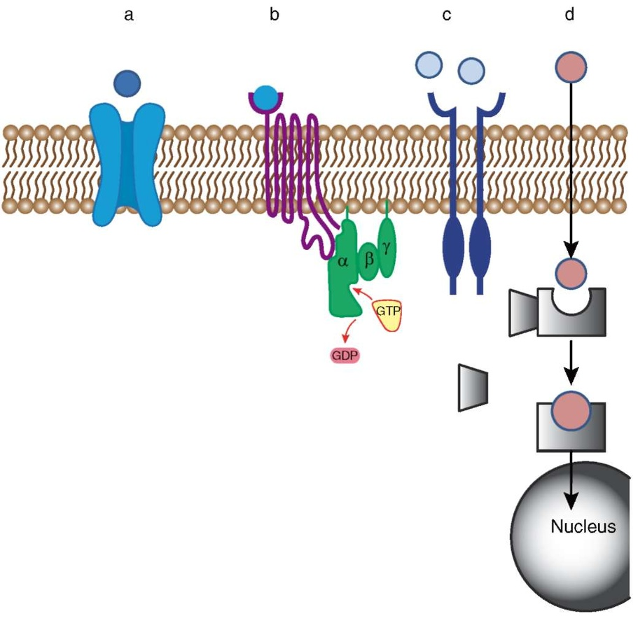

Fig. 1.1. Receptors can be coupled with ion channels (a); with a second messenger system (b); with a membrane enzyme [tyrosine kinase (c)]; or located inside the cell (d)
D. Receptors regulating gene transcription.
Receptors regulating gene transcription are termed nuclear receptors. Some of them are located in the cytoplasm and migrate to the nucleus only after binding to a ligand. Specifically, lipophilic glucocorticoids easily pass through the cellular membrane and bind to their appropriate receptors in the cytoplasm, releasing the heat shock protein. The receptor-glucocorticoid complex penetrates the nucleus and stimulates or represses transcription factors.
The strength of a substance binding to its receptor can be described by affinity.
Affinity is the ability of a substance to bind to a biological target (receptor), resulting in a formation of a "substance-receptor" complex. It is a measure of the ligand's ability to bind to the receptor by electrostatic interaction. Inaccordance with the law of mass action, the speed of reaction is proportional to the product of the reagents' concentrations.
The ability of a substance with binding affinity (a ligand) to activate receptors is termed "intrinsic activity".
Intrinsic activity refers to the ability of a ligand once bound to the receptor to produce a functional response. Depending on the type of interaction between the ligand and receptor, a distinction is made between full agonists, partial agonists, antagonists and inverse agonists (which can also be subdivided into full and partial).
The polymorphism of types of ligand-receptor interaction is described by a theory which specifies, as a minimum, two conditions of a receptor: active (R_{a}) and inactive (R_{i}), which exist in dynamic equilibrium. The receptor's condition can change either spontaneously or under the effect of a ligand (fig. 1.2).
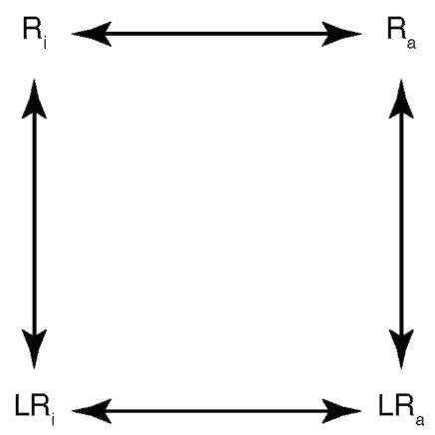
Fig. 1.2. Receptors can exist in two conformational states: inactive (rest; R_{i}) and active (R_{a}), which are in equilibrium with one another. At rest, without a ligand, the dynamic equilibrium shifts to the left. Receptors without a ligand can spontaneously change their state. The binding of ligands to the receptors may shift the equilibrium
Agonists (from Greek agonistes - rival, agon - rivalry) are substances with affinity and intrinsic activity. When interacting with specific receptors, agonists stimulate them, i.e. cause changes in conformation of the receptors, triggering a chain of biochemical reactions inside the cells which results in development of certain pharmacological effects.
Based on this theory, full agonists are MSs which bind to receptors and produce the maximal cellular response; intrinsic activity of full agonists amounts to 100%. Full agonists bind to and facilitate activation of receptors (fig. 1.3, a).
Partial agonists are MSs with the intrinsic activities greater than 0, but less than 100%. In this respect, they bind to receptors; however, not all receptors to which they bind are activated. Therefore partial agonists cannot be as effective as full agonists (see fig. 1.3, b).
Competitive antagonists have affinity but no intrinsic activity (0); they bind to receptors in both active and inactive states. Affinity to receptors in various states may be different (see fig. 1.3, c). By binding to receptors, they prevent the action of either endogenous ligands (such as neurotransmitters and hormones), which are full agonists to these receptors, or exogenous agonists (including drugs). Therefore antagonists are also termed receptor blockers. Pharmacological effects of antagonists are possible through elimination or suppression of the action of endogenous ligands to these receptors (neurotransmitters, hormones etc.); thus they are opposite to the effects of agonists.
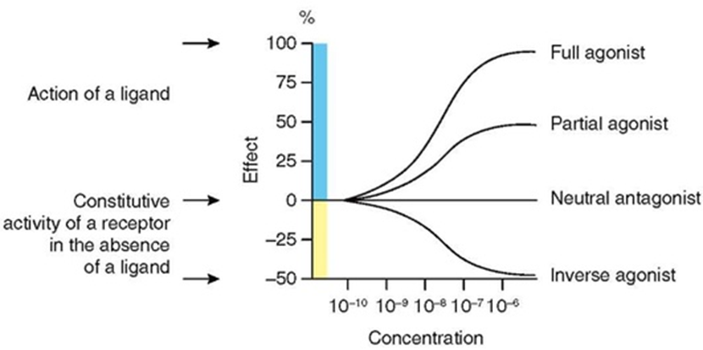

Fig. 1.3. Influence of ligands with different intrinsic activity on effects caused by stimulation of receptors
Inverse agonists reduce the quantity of spontaneously activated receptors by binding to the receptors in inactive state (R_{i}), and decrease the level of spontaneously formed second messengers (see fig. 1.3, d). In most cases in daily practice inverse agonists reveal competitive antagonist properties.
If antagonists occupy the same binding sites as agonists, they can displace each other from the bond with the receptor. This type of antagonism is termed competitive antagonism, whereas such antagonists are referred to as competitive. Competitive antagonism depends on relative affinity of competing substances to the cognate receptor and their concentration. In sufficiently high concentrations, a substance with lower affinity can displace a substance with higher affinity from the receptor bond. Therefore in competitive antagonism the effect of an agonist can be fully recovered by increasing its concentration in the medium. Competitive antagonism is often used for elimination of toxic effects of a medicinal agent.
Noncompetitive antagonism occurs when an antagonist occupies the so-called allosteric binding sites on receptors (macromolecule non receptor sites that regulate receptor activity). Upon binding to these sites, noncompetitive antagonists change the receptors' conformation in a way that the latter lose the ability to interact with agonists. In this case, an increase in the concentration of an agonist cannot fully recover its effect.
The two crucial parameters, potency and efficacy, can be determined on the basis of dose-effect gradual curves.
MS potency is determined by concentration (ЕС₅₀) in which the substance produces 50% (half-maximal) effect.
Efficacy (Е_{max}) is the maximum effect which can be expected from the medicinal agent.
Fig. 1.4 shows dose-effect curves for substances А, B and C. Experimentally obtained on an isolated organ, these curves enable evaluation of such parameters as potency and efficacy. Since all curves end up in a "plateau", at a certain concentration of a substance in solution all receptors will be occupied by the test substance. Substance A is a reference standard of activity and efficacy. Substance B can produce an identical effect but in higher concentration, therefore Substance A is more active than Substance B but their efficacy is equal. Substance C reaches the plateau at a lower efficacy and at a higher concentration. Hence, its potency and efficacy are lower than those ofSubstances A and B.
Types of Pharmacological Actions of Drugs
As a rule, each substance produces a number of its characteristic pharmacological effects. In each individual case, only certain required effects of the medication are used. Thus, the specific effect (specific action) is the action of a medication that is the main reason for its clinical use. Along with specific action, many drugs have a side, adverse action. Side (adverse) effects are undesired effects that occur along with the specific action even in therapeutic doses (fig. 1.6).
Therapeutic Window
Doses of medications can be:
• threshold (minimum action);
• mean therapeutic (single, daily, course);
• maximum therapeutic;
• loading;
• saturating;
• maintenance.
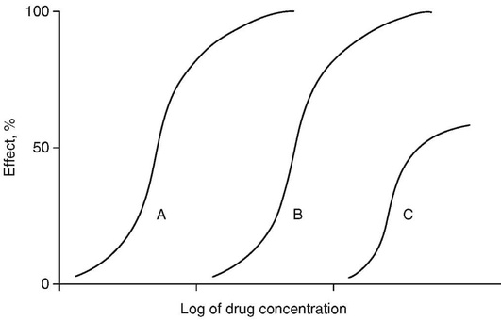
Fig. 1.4. Potency and efficacy of drugs. Efficacy of substances A and B is the same but Substance A is more active. Substance C has lower activity and efficacy
The range from the minimal effective dose to the maximal therapeutic dose is called the therapeutic range (therapeutic window). Therapeutic window (safety window) is a range of doses (concentrations) of an MS that produces a therapeutic response without causing any unacceptable, harmful for health (toxic) effects in patients. Plasma concentrations of MSs with a narrow therapeutic window must be thoroughly controlled to maintain effective dosing of these substances and must not exceed the levels above which toxic effects may occur. The therapeutic index (also referred to as therapeutic ratio) (fig. 1.5) is commonly used to quantify the therapeutic window:
Therapeutic index (TI)_{D} = TD₅₀ / TE₅₀,
where TD₅₀ is the dose that produces a toxic effect in 50% of the population, ТЕ₅₀ - the dose that produces a therapeutic effect in 50% of the population.
Therapeutic index is a quantitative measurement of the relative safety of a MS among the members of one population.
Depending on the route of administration and localization of pharmacological effects, the following types of pharmacological actions of drug are distinguished.
• Resorptive action (from Latin resorbtio) manifests after a substance has been absorbed into the bloodstream and distributed throughout the body. Such action is typical of most medicines when administered orally or parenterally.
• Local action occurs in the event of direct contact between the drug and the body tissues, e.g. skin or mucosa. Local action also includes response of tissues (subcutaneous fatty tissue, muscles etc.) to the injection.
• Reflex action occurs in response to stimulation of an afferent part of the reflex arc in order to obtain an effect in the efferent innervation area. For instance, stimulation of skin receptors by oil of mustard (mustard plaster) improves blood supply of both skin and subjacent tissues.
Side (adverse) Effects
Side effects can be allergic or non-allergic. Allergic responses:
• are similar in all medicinal substances;
• are practically dose-independent (i.e. can occur in response to small doses);
• can be alleviated by use of anti-allergic substances.
In terms of severity, allergic responses can be:
• mild (skin itchiness, rash);
• medium severity (Quincke's angioedema, serum disease);
• severe (anaphylactic shock). Non-allergic side effects:
• are MS-specific;
• increase along with an increase in the dose;
• can be eliminated by use of specific antagonists.
A special type of side action is prenatal development disorders caused by consumptionof medications bypregnant women.
Prescription of certain drugs during the first trimester of pregnancy causes teratogenic or
embryotoxic effects. A teratogenic effect is
an action on the fetus resulting in congenital deformity. An undesired effect which is not resulting in embryo deformity is termed embryotoxic.
A fetotoxic effect is an adverse effect of medicines on the fetus during the second half of pregnancy.
MS action in doses exceeding the therapeutic maximum produces a toxic effect on the body and manifests in severe dysfunction of renal, hepatic, blood circulation, central nervous system, gastrointestinal and other systems.
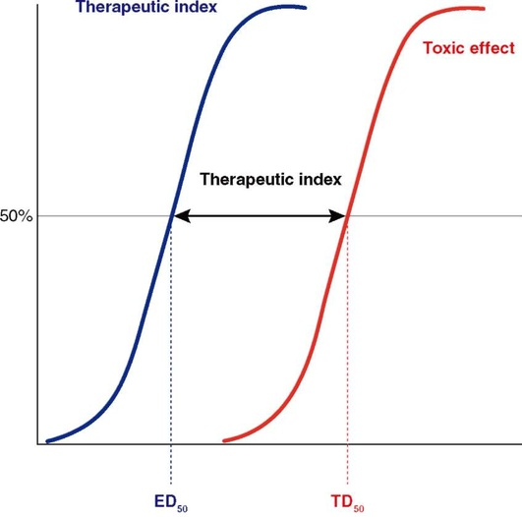
Fig. 1.5. Therapeutic index is a resultant parameter derived from ED₅₀ and TD₅₀
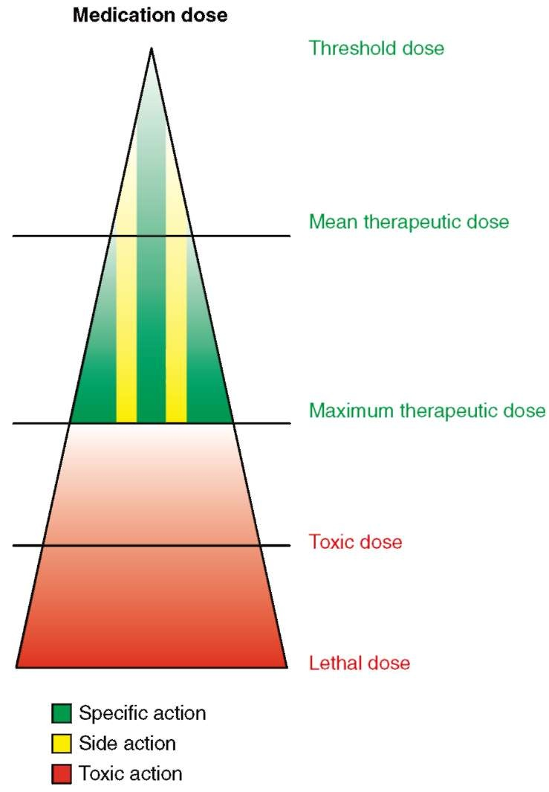
Fig. 1.6. Specific and side effects develop simultaneously when a medication is used in a therapeutic dose. Evaluation of undesired responses to the medication should take into account the dose in which the medication was prescribed and foreclose the possibility of a toxic effect

Pharmacokinetics encompasses the processes of absorption, distribution, deposition, transformation and excretion of medicinal substances (MSs). To reach the required organ or target cell, the MS has to be absorbed into the bloodstream passing through the gastrointestinal tract mucosa (in the event of oral intake) or through the blood vessel wall (in the event of parenteral administration), and then it should leave the bloodstream to render a pharmacological effect. In this case from the point of view of the body, the medication is a xenobiotic chemical compound that has to be transformed (metabolized) into a hydrophilic metabolite (highly soluble substance), and then excreted.
2.1. ABSORPTION
There are four ways for a substance to pass through the biological membranes (listed in the order of frequency of use in pharmacology):
• diffusion (passive or facilitated);
• paracellular transport (also referred to as filtration);
• active transport;
• pinocytosis, endocytosis.
Passive diffusion is the predominant mechanism of drug transport across cell membranes along a concentration gradient. Since cell membranes are mostly composed of lipids, lipophilic nonpolar substances, i.e. highly lipid-soluble substances that have no electrical charge (fig. 2.1) can easily penetrate the membrane via passive diffusion.
On the contrary, hydrophilic polar substances, i.e. highly water-soluble substances that have an electrical charge, cannot cross the cell membrane easily through passive diffusion (see
fig. 2.1).
Facilitated diffusion is the process of passive transport of substances along the concentration gradient, facilitated by transport proteins which can be ion channels or transporters. This type of absorption is selective, saturable and does not require additional energy.
MS paracellular transport occurs mostly in the capillary endothelium, through the intercellular spaces in between epithelial cells viaplasma flow. Hydrophilic polar substances pass through the intercellular spaces via filtration. The degree of their filtration depends on the size of intercellular spaces. In the vascular endothelium of peripheral tissues (muscles, subcutaneous fatty tissue, internal organs) the intercellular spaces are large enough so most hydrophilic polar MSs may easily pass through them via paracellular transport. In the meantime, the substances enter the bloodstream from the tissues and the tissues from the bloodstream along the concentration gradient. However, in the gastrointestinal tract paracellular transport is limited due to tight junctions: an extra connection between the intestinal epithelial cells. Drugs which cannot be absorbed in the gastrointestinal tract are administered parenterally.
MS paracellular filtration is impossible in the brain capillaries where the endothelium has no intercellular spaces and endothelial cells are additionally connected by the so-called protein locks: tight junctions (zonulae occludentes) (see fig. 2.1). Vascular endotheli-um of the brain forms a barrier which impedes passage of hydrophilic polar substances from the bloodstream into the neural tissue - the blood-brain barrier. Lipophilic nonpolar substances cross the blood-brain barrier via passive diffusion more easily. However, some lipophilic compounds (e.g. Loperamide, Pacli-taxel, etc.) cannot penetrate the brain, being "pumped out" by the dedicated transporter systems (e.g. P-glycoprotein) on the brain vascular endothelium level.
Active transport refers to a transport process in which MS are transported across the membranes with the aid of special transport systems (typically protein molecules). The quantity of such transport systems in a membrane is limited, and each transporter is specific for the transported substance. This explains why active transport is:
• selective;
• saturable (i.e. has quantitative limits per unit of time);
• requires energy;
• can occur against the concentration gradient
(fig. 2.2).
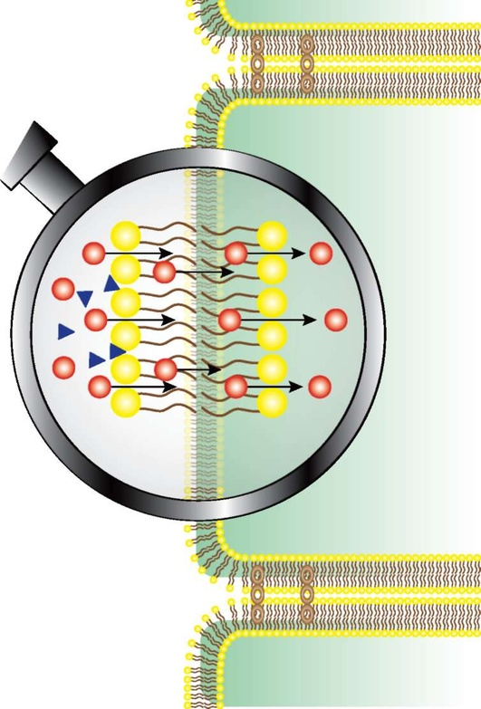

Fig. 2.1. Transport of drugs across biological barriers depending on their physical and chemical properties (hydroand lipophilicity, ionization, polarization capacity). Red balls are lipophilic compounds. Blue triangles are hydrophilic compounds
Active transport is used for movement of-such substances as amino acids in the gastrointestinal tract and brain (fig. 2.2).
Pinocytosis (from Greek pinō - drink, ingest + cytus - cell) is active ingestion of extracellular fluid by a living cell resulting in formation of up to 0.1 мm fluid-containing vesicles in the cytoplasm. The significance of pinocytosis in MS transport is negligible.
Endocytosis is a process of uptake of a substance by the cell after binding to a cognate receptor (e.g. lipoproteins).
2.2. DISTRIBUTION
Distribution of medicinal substances in the body is non homogeneous. Drug absorptive capacity differs greatly across organs and tissues in proportion to their blood supply.
Drug distribution in organs and tissues depends on several factors:
• structure of a medicinal substance (the higher the lipophilicity of a drug, the better the drug deposition in the adipose tissue and
cells);
• blood supply of the organs (direct corr elation);
• structure of vessels (size of endothelial cell fenestrae);
• presence of blood-tissue barriers;
• deposition in organs and tissues.
Along with that, when evaluating distribution in liquid environments, one can distinguish (mostly in a relative way) three main volumes (the so-called compartments) in which the medicinal substance can be distributed depending on the size, physical and chemical properties, ability to bind to plasma proteins (see fig. 2.3):
• blood plasma;
• extracellular fluid;
• cytoplasm.
This process is characterized by the so-called volume of distribution (apparent volume of distribution). This is a hypothetical volume of liquid at which the entire amount of the drug is evenly distributed in a concentration equal to its concentration in the blood plasma (fig. 2.3).
Volume of distribution:
Vd = D/Ср,
where D - dose of the administered drug; Ср - concentration of the drug in blood plasma.
2.3. DRUG METABOLISM
Most MSs undergo modifications (biotransformation) in the body via enzymatic reactions. Drug metabolism is carried out by kidneys, gastrointestinal tract, lungs, skin and other organs. Still, most enzymes are encountered in the liver, which makes it the key contributor to MS biotransformation. Most MSs are metabolized by microsomal enzymes located in the hepatocyte endoplasmic reticulum. Therefore, the ability of the liver to transform medications depends on the ability of the drug to penetrate hepatocytes. That is why the liver actively metabolizes lipophilic (hydrophobic) MSs. As a result of metabolic transformations, drugs become more hydrophilic; this facilitates and accelerates their urinary excretion.
Enzyme systems activity depends on the person's sex, age, liver condition, and combined administration of medications. In newborns, the microsomal enzyme system is immature; therefore, certain MSs are not administered in the first weeks of life due to their pronounced toxic action. For instance, chloram-phenicol intake results in an onset of the so-called gray baby syndrome which manifests in circulatory collapse, bluish gray color of the skin etc. due to a direct toxic effect of the drug on the myocardium.
Reduced activity of microsomal enzymes (in advanced age or hepatic disorders) decelerates biotransformation of medicinal substances, whereas their action becomes more pronounced and prolonged. Therefore, many medications are prescribed to patients over 60 in a lesser dose compared with middle-aged patients.
Certain MSs termed microsomal enzyme inhibitors or inducers impact the potency of hepatic microsomal enzymes and alter the action of other drugs. Concurrent prescription of such medications as glucocorticoids or contraceptives can result in a weakened effect of the
latter (table 2.1).
There are two types of metabolic reactions of biotransformation:
• Phase 1 (oxidation/reduction/hydrolysis);
• Phase 2 conjugation (reactions of acetyla-tion, methylation, forming compounds with glucuronic acid etc.).
Products of transformation are termed metabolites and conjugates, respectively. As a rule, they are less active than the original compounds. However, at times metabolites are more active than the original compounds or acquire specific activity absent in the orig-
Before prescription of prodrugs, in particular Clopidogrel, one must make sure that the enzyme transforming the prodrug into an active compound is itself active. The problem is that polymorphism in the gene coding the enzyme can result in a loss of activity of the latter and cause its metabolic disturbance (table 2.2).
2.4. DRUG EXCRETION
Drugs are excreted by the liver, kidneys, intestines, lungs, mammary glands, and other excretory glands. However, the primary organs responsible for excretion of MSs and their metabolites are the kidneys. Excretion of MSs can occur passively via glomerular filtration and actively via tubular secretion using specialized transport systems. The rate of renal drug excretion can be limited by active and passive reabsorption processes.
Renal glomeruli filter substances with molecular mass up to 5000-10,000 unbound to the blood plasma proteins. Below are the main characteristic parameters of the process of drug excretion.
The elimination rate constant (k_{el}, min⁻¹) represents the fraction of drug excreted (eliminated) from the body per unit of time:
K_{el} = A_{exc} /А_{tot},
where А_{exc} - amount of the drug that is excreted per unit of time, А_{tot} - total amount of the drug in the body.
[K_{el}] = h⁻¹ /min⁻¹ = fraction per hour.
K_{el} is typically found by solving a pharmacokinetic equation describing the process of drug elimination from the blood; therefore, k_{el} is referred to as the model kinetic metric.
The elimination constant is directly proportional to clearance and inversely proportional to the volume of distribution (from the definition of clearance):
[K_{el}] = Cl / V_{d}.
Half-life (elimination half-life) (t_{1/2}, min) is the time required to eliminate 50% of the drug from the blood. In this case, it does not matter which way is used to reduce the concentration: biotransformation, excretion, or a combination
of both processes. Elimination half-life is calculated by the formula:
t_{1/2} = ln2/ K_{el} = ln2 ×V_{d} / Cl
Half-life is a central pharmacokinetic factor enabling:
a) calculation of the time to achieve equilibrium concentration (equal to 4-5 periods of elimination half-life);
b) determination of the time of full elimination of the drug;
c) prediction of the drug concentration at any given moment of time (for medications with first-order kinetics).
Drug Administration at a Constant Rate. Steady State Drug Concentration (C_{SS}) in the Blood. Time of its Achievement¹
Drug administration at a constant rate aims at gradual change of its concentration in the blood during administration (see fig. 2.4), whereas:
1) the time of achievement of steady state drug concentration amounts to 4-5 t_{1/2} and does not depend on the rate of infusion (amount of the administered dose);
2) with an increase of infusion rate (administered dose) the С_{SS} value also increases by a proportional number of times;
3) elimination of the drug from the bodyafter the end of infusion takes 4-5 t_{1/2}.
С_{SS} is the equilibrium steady state concentration; concentration ofthe drug achieved at the administration rate equal to the excretion rate, hence this value can be derived from the definition of clearance:
Cl = elim. rate / [conc]. = admin. rate / C_{ss}
C_{SS} = admin. rate / Cl = D/time / Cl = D/ДT / Cl.
Each subsequent half-life period gives an increment of drug concentration by 50% of the remaining concentration (fig. 2.5).
All drugs abiding by the law of first-order elimination will reach C_{SS}within 4-5 half-life periods.
Approaches to С_{SS} level management:
1) change administered dose of the drug (D);
2) change administration interval (ДT).
¹ This topic is considered at the end of the chapter because MS concentration during administration at a constant rate depends on several pharmacokinetic parameters, including elimination constant and t_{1/2}.
Table 2.1. Inducers and inhibitors of the most important microsomal hepatic enzymes
CYP1A2 | CYP2C9 | CYP2C19 | CYP2D6 | CYP3A4
Inhibitors
Ciprofloxacin | Amiodarone | Fluoxetine | Duloxetine | Indinavir
Ofloxacin | Fluconazole | Fluvoxamine | Fluoxetine | Ritonavir
Levofloxacin | Isoniazid | Lansoprazole | Paroxetine | Clarithromycin
Amiodarone | Sulfonazole^{ρ} | Omeprazole | Amiodarone | Erythromycin
Cimetidine | Phenylbutazone | Ketoconazole | Bupropion | Fluconazole
Fluvoxamine | Fluvastatin | Ticlopidine | Cimetidine | Ketoconazole
Ticlopidine | Diclofenac |  | Quinidine | Diltiazem
 |  |  | Ritonavir | Verapamil
Inducers
Tobacco smoking | Rifampicin |  |  | Hypericum
Omeprazole |  |  |  | Carbamazepine
 |  |  |  | Efavirenz
 |  |  |  | Grapefruit
Table 2.2. Genetic polymorphisms that influence drug efficacy
Polymorphism of the gene coding the enzyme | Medicinal substances | Identified effect
CYP2C9 | Barbiturates, Warfarin, Phenytoin, nonsteroidal anti-inflammatory drugs | Increased anticoagulation effect of Warfarin
CYP2C19 | Clopidogrel, Omeprazole, Phenytoin, Propranolol | Reduction in efficacy of Clopidogrel, response to Omeprazole
CYP2D6 | Antipsychotic drugs, beta-blockers, Codeine, Phenacetin^{ρ}, Propafenone | Late dyskinesia in case of antipsychotics, efficacy and dependence in case of opiates
CYP3A4/3A5 | Cyclosporine, macrolides, Tacrolimus, calcium channel blockers, Lidocaine, steroids | Change of Tacrolimus dose

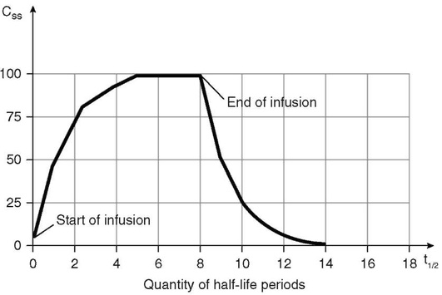

Fig. 2.4. Schematic representation of drug administration at a constant rate
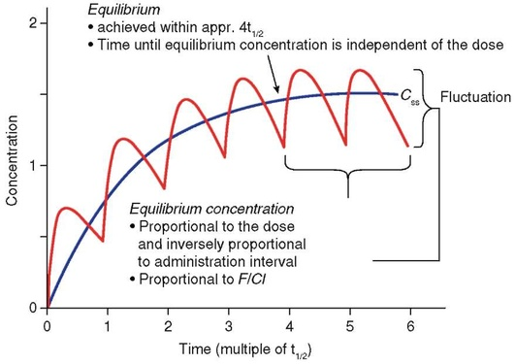
Fig. 2.5. Schematic represantation of drug administration at a constant rate
Intermittent Drug Administration. Calculation of Steady State Concentration (C_{SS})
Intermittent drug administration isadmi-nistration of a certain amount of drug over a set period of time (fig. 2.6).
The equilibrium steady state concentration in this schematic representation of administration will be achieved within 4-5 half-life periods.
The time of its achievement does not depend on the dose (initially when the drug concentration level is low, its elimination rate is also low; an increase in the concentration of a substance in the body causes increase of its elimination rate; therefore, sooner or later, there will come a moment when the increased rate of elimination balances the dose of administered drug and there will be no further increase in concentration). С_{SS} = MD / Cl × ДT.
С_{SS} is directly proportional to the drug maintenance dose and inversely proportional to the administration interval (ДT) and drug clearance (Cl).
С_{SS} variation limits:
С_{SS}^{max} = MD / (Vd × el. fr.). С_{SS}^{min} = С_{SS}^{max} × (1 - el. fr.).
Drug concentration variation is proportional
Adequate administration schedule for discrete doses. In this schedule of administration, the fluctuation (variation) of drug concentra-
tion in blood remains within the therapeutic window, with the difference between С_{SS}^{max} and С_{SS}^{min} not exceeding 2×С_{SS}.
С_{SS} variations management: С_{SS} variation amplitude is directly proportional to drug dose and inversely proportional to the interval of its administration.
1. Change drug dose: an increase of the drug dose will lead to proportional increase of С_{SS}variation range.
2. Change drug administration interval: an increase of the drug administration interval will lead to proportional decrease of С_{SS} variation range.
3. Simultaneously change the dose and administration interval.
Initial (Loading) Dose
Initial (loading) dose is a dose administered in one session and filling the entire volume of distribution in the effective therapeutic concentration.
Loading dose = (С_{SS} ×Vd) / F,
where С_{SS} - equilibrium steady state concentration; Vd - apparent volume of distribution; F - bioavailability.
Therapeutic purpose. The loading dose quickly provides the required effective therapeutic concentration of the drug in the blood, making it possible to stop quickly an asthma attack, arrhythmia etc.
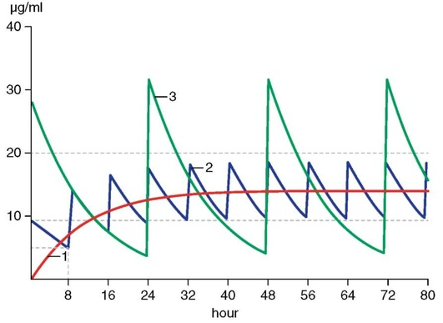
Fig. 2.6. Schematic representation of drug intermittent administration. Fluctuation of drug plasma concentration: 1 - constant intravenous drop administration; 2 - intermittent administration of the same daily dose with an 8 hour interval; 3 - administration of a daily dose with a 24 hour interval
The loading dose can be administered in one session only if the substance distribution process is ignored.
Use restrictions of loading dose. If drug distribution occurs significantly slower than its delivery to the bloodstream, then administration of the entire loading dose in one sitting (especially intravenously) will result in a concentration which is significantly higher than the therapeutic dose and will lead to emergence of toxic effects.
Use conditions of loading dose.
Administration of loading doses should always be slow (or intermittent).
If the drug is not intended for control of emergency conditions or is administered in tablets, the loading dose is not calculated.

DEPENDENCE OF PHARMACOTHERAPEUTIC ACTION ON DRUG PROPERTIES AND PATTERN OF USE
A) Chemical structure, physical-chemical and physical properties of drugs
Drug properties depend on their chemical structure, presence of functionally active groups and shape and size of their molecules to a significant extent. The effective interaction of a drug with a receptor requires a structure that provides their closest contact. The strength of intermolecular bonds depends on the degree of drug-receptor proximity. Thus, it is known that in an ion bond the electrostatic attraction of two opposite charges are in inverse proportion to the squared distance between them, and Van der Waals forces are in an inverse proportion to 6-7th power of distance
Elucidation of dependence between chemical structure of substances and their biologic activity is one of the most important directions in creating new drugs. Besides, comparison of optimal structures of different chemical groups with similar mechanism of action allows us to formulate an understanding of the organization of those receptors that the drugs interact with.
Most quantitative and qualitative characteristics of drug effect also depend on such physico-chemical and physical properties as solubility in water and lipids. The characteristics of powdered compounds depend on the size of the particles, the volatile substances - on volatility range, etc. Ionization rate is of great importance. For instance, muscle relaxants, structurally related to secondary and tertiary amines, are less ionized and less active than completely ionized quaternary ammonium compounds.
B) Doses and concentrations
Drug action is defined by their dose to a great extent. Changes in their dose (concentration) influence speed of onset of effect, its intensity, duration and sometimes modality. Usually an increase in dose (concentration) minimizes latent period and increases intensity and duration of the effect.
Dose is the amount of a substance per one intake (usually designated as a single dose).
It is necessary to be aware not only of the dose meant for one intake (pro dosi), but also of the daily dose (pro die).
Dose is measured in grams and gram fractions. For more accurate dosing of drugs their amount is counted per 1 kg of body mass (for example, mg/kg, microgram/kg). In some cases drug dosage is preferably counted by body surface area (per 1 m²).
Minimal doses, in which drugs cause primary biologic effect, are called threshold, or minimally active. Practical medicine usually uses average therapeutic doses, i.e. doses in which drugs cause necessary pharmacotherapeutic action in the majority of patients. If after administration of these doses the effect is not marked enough, the dose is increased up to the maximum therapeutic one. Toxic doses are doses in which drugs cause harmful toxic effects on the organism

C) Repeated administration of drugs
In repeat drug administration their effect may both increase and decrease.
The increase in effect of a number of drugs is associated with their ability to accumulate (cumulation¹). Cumulation means storage of pharmacological substance in the body. It is typical for long-acting drugs that are released slowly or are steadily bound in the body (for example, some cardiac glycosides from the Digitalis group). Cumulation of drug after repeated administration may be the cause of toxic effects. Therefore such drugs have to be dosed considering cumulation, by gradually decreasing the dose or increasing intervals between drug intakes.
Decrease of drug effect after repeated administration (tolerance²) is observed with various drugs (opioid analgesics, antihypertensives, laxatives, etc.). It may be associated with the decrease in drug absorption, increase in its inactivation rate and (or) increase in
¹ From Latin cumulus - a heap.
² From Latin tolerare - to endure.
elimination. Tolerance to a number of drugs may be associated with a decrease in sensitivity of receptors (desensetization) to them or with a decrease in the number of these receptors in tissues (downregulation).
When tolerance develops, for the initial effect the drug dose needs to be increased or the drug has to be substituted with another one. If substitution is considered, it has to be remembered that cross-tolerance to the drugs, interacting with the same receptors (substrates), may occur.
A special type of tolerance is tachyphylaxis¹ - tolerance that occurs very quickly, sometimes after the first administration of a drug. For example, ephedrine, being repeatedly administered with the interval of 10-20 min, causes a smaller increase in arterial blood pressure after subsequent doses compared with the first injection.
Repeated administration of some drugs (usually neurotropic) leads to the development of drug dependence (Table II.5). It appears as a compulsion to take a drug, usually for the purpose of improving mood, well-being and deceasing unpleasant experiences and symptoms, including symptoms of withdrawal of the offending drug. Psycho logical and physical drug dependence can be distinguished. In case of psychological drug dependence discontinuation of drug administration (for example, cocaine, hallucinogens) causes only emotional discomfort. Physical drug dependence develops after the administration of some drugs (morphine, heroin). It is a more severe stage of dependence. Discontinuation of the drug in this case causes severe health conditions which, besides dramatic psychological changes, include various and often serious somatic disorders, associated with dysfunction of most body systems. It may even lead to death. This is called abstinence syndrome², or withdrawal effect.
D) Drug interactions
In medical practice patients often take several drugs simultaneously. These drugs may interact with each other, changing intensity and character of the basic effect and its duration as well as intensifying or weakening adverse and toxic effects.
¹ From Greek tachys - quick, phylakterion - protection.
² From Latin ab - of, away; tenere - to hold; Greek: syn - with, drome - run.
Drug interaction may be classified in the following way.
• Pharmacological interaction:
- based on the change in drugs pharmacokinetics;
- based on the change in drugs pharmacodynamics;
- based on the change of physico-chemical interaction of drugs in the body media.
• Pharmaceutical interaction
Combinations of different drugs are often used for intensifying or combining effects useful for medical practice. For example, adding certain psychotropic drugs to opioid analgesics substantially increases pain-relieving effect of the latter. Drugs that contain antibacterial and antifungal agents with steroid anti-inflammatory substances can be another useful combination. There are quite a few such examples. At the same time combining drugs can lead to adverse effects, and this is called drug incompatibility. This incompatibility is manifested either by weakening, full loss or change of character of the pharmacotherapeutic effect, or by intensifying side or toxic effects (so-called pharmacological incompatibility). It can happen with combined administration of two or more drugs. For instance, drug incompatibility may be the cause of hemorrhages, hypoglycaemic coma, seizures, hypertensive crises, pancytopenia, etc. Incompatibility may also occur in preparation and storage of drugs combination (pharmaceutical incompatibility).
A. Pharmacological interaction
Pharmacological interaction occurs when one drug changes the pharmacokinetics and (or) pharmacodynamics of the other drug. Pharmacokinetic type of interaction can be associated with the failure of absorption, metabolism, transport, storage and elimination of one of the drugs. Pharmacodynamic type of interaction is the result of direct or indirect drug interaction on the level of receptors, ion channels, cells, enzymes, organs or physiologic systems. In this case the main effect may change in quantity (be intensified or weakened) or in quality. Also, chemical and physico-chemical drug interaction can occur after combined administration of two or more drugs.
Pharmacokinetic type of interaction (Table II.6) can appear even at the stage of drug absorption, this can change due to different reasons. Examples are: binding of drugs by adsorbing agents (activated charcoal, kaolin) or by anion-exchange resin (for example, hypolipidemic cholestyramine) in the digestive tract, formation of inactive chelating compounds (for example, interaction between tetracycline antibiotics and iron, calcium or magnesium ions). All these types of interaction prevent drug absorption and decrease their pharmacotherapeutic effects accordingly. pH medium is of substantial significance for absorption of a number of drugs. By changing pH of digestive juices it is possible to significantly affect the rate and range of week organic acids and bases absorption. It has been noted that decreasing ionization levels leads to an increase in lipophility of such substances, and this promotes their absorption.
The change in digestive tract peristalsis also affects drug absorption. Increases in peristaltic action caused by cholinomimetics decreases absorption of cardiac glycoside digoxin, while atropine (blocker of muscarining cholinoceptors), decreasing peristalsis, favors digoxin absorption. There are also examples of drug interaction on the level of their penetration through the intestinal mucous membrane (for example, barbiturates decrease absorption of antifungal drug griseofulvin).
Inhibition of enzyme activity may also affect absorption. Thus, antiepileptic drug phenytoin inhibits folate deconjugase and impairs absorption of folic acid from food. It results in the development of folic acid deficiency.
Some drugs (almagel, liquid petrolatum) form a layer on the surface of the digestive tract mucous membrane that may hinder drug absorption.
Drug interaction can also occur at the stage of their binding with serum proteins (mainly with albumins). One drug may displace another from the complex with plasma proteins. Thus, anti-inflammatory drugs indomethacin and phenylbutazone release indirect anticoagulants (coumarin groups) from the complex with plasma proteins. Concentration of the free fraction of anticoagulants increases, which may lead to hemorrhages. In a similar way phenylbutazone and salicylates increase plasma concentrations of the free fraction of hypoglycaemic drugs (chlorpropamide-like) and may cause hypoglycaemic coma.
Some drugs are able to interact on the level of drug biotransformation. There are drugs which increase (induce) activity of the microsomal enzymes of the liver (phenobarbital, phenytoin, griseofulvin, etc.). The metabolism of most drugs increases in the presence of these drugs, and this decreases intensity and duration of their effect (as well as activity of enzymes inducers themselves). However, in clinical settings this interaction manifests distinctly enough only with the use of large doses of enzyme inducers for quite a long period of time.
Drug interaction can result from the inhibition of microsomal and nonmicrosomal enzymes. For example, xanthine oxidase inhibitor (gout treatment medication allopurinol) increases toxicity of antitumor drug mercaptopurin (intensifies its depressing action on hematopoiesis).

Elimination of drugs can also be substantially changed with combined drug administration. It has been already noted that reabsorption of week organic acids and bases in renal tubules depends on pH values of the primary urine. It is possible to increase or decrease the degree of ionization of the drug by changing its pH. The lower the ionization, the higher the lipophility of the drug and the more intensive its reabsorption in the renal tubules. More ionized drugs are poorly reabsorbed and are eliminated with urine to a greater extent. Sodium hydrocarbonate is used to alkalize urine, ammonium chloride is used to acidify it (there are other drugs with similar action). In combined drugs administration their secretion in the renal tubules may be impaired.
One compound can intensify or weaken the effect of the other one. In case of synergism¹ drug interaction leads to an increase in effect.
Drug synergism may present either as a simple summing up or potentiation of effect. Summed (additive²) effect represents the actual sum of effects of the individual drugs (for example, this is how additive effects of anesthetics occur). If during the administration of two drugs the total effect exceeds (sometimes significantly) the sum of both drug effects, it indicates potentiation (for example, antipsychotic drugs potentiate the effects of general anesthetics).
Synergism may be direct (if both compounds affect one substrate) or indirect (if their effects have different localization).
The ability of a drug to decrease the effect of the other one is called antagonism. By analogy with synergism, direct and indirect antagonism are distinguished (interaction on the level of receptors is described above).
¹ From Greek syn - together, ergos - work.
² From Latin addition-ad - to; addere - to put.
B. Pharmaceutical interaction
There are cases of pharmaceutical incompatibility when during the production process, storage or mixing of the drugs in one syringe interaction of the components of the mixture occurs. The resultant changes can cause the drugs to become unsuitable for common use. At the same time pharmacotherapeutic activity of the initial components decreases or disappears. In some cases new and sometimes adverse (toxic) properties appear.
Pharmaceutical incompatibility can be associated with chemical, physical and physico-chemical properties of substances. For example, incompatibility may be caused by insufficient or total insolubility of substances in a solvent, coagulation of drug formulation, emulsion layering, dampening and melting of powders due to their hygroscopic property. When drugs are co-prescribed by mistake, there may be a change in color, taste, smell or consistency of the drug formulation as a result of chemical interaction.

IMPORTANCE OF INDIVIDUAL CHARACTERISTICS OF THE HUMAN BODY AND ITS STATE FOR THE MANIFESTATION OF THE DRUG EFFECT
A) Age
Sensitivity to drugs changes with age. That is why so-called perinatal pharmacology that studies specificities of drug effect on the fetus (from 24 weeks of pregnancy up until delivery) and on the newborn (up to 4 weeks of life) is distinguished. With regard to drug sensitivity, a fetus in the last trimester and newborns in the first month of life are significantly different from adults. This is mainly due to the insufficiency of most enzymes, renal function, increased permeability of the blood-brain barrier and the underdevelopment of the CNS. During this period of life, receptors have different sensitivity to drugs. The field of pharmacology, studying specificities of drug effects on child's organism, is called pediatric pharmacology.
In elderly and old patients drug absorption is delayed, their metabolism is less effective, drugs elimination via kidneys is reduced. In general, sensitivity to most drugs in elderly and old patients is increased, and therefore the doses should be reduced. Besides minimally toxic drugs should be selected for use in this population.
It is important to know specificities of drug effect in elderly and old patients (socalled geriatric¹ pharmacology) because the proportion of these age groups among the general population has significantly increased.
B) Gender
Animal experiments have shown that males are less susceptible to a number of substances (nicotine, strychnine), than females. Some differences in the metabolism of some drugs are also associated with gender. There are also some clinical observations. For example, paracetamol clearance occurs faster in males than in females. In menopausal females, intestinal absorption of calcium ions is delayed. Bioavailability of verapamil in females is higher than in males. Oxygenation of diazepam occurs faster in females. Antiarrhythmic drugs cause arrhythmogenic effect (so-called «torsade de pointes») in females more often than in males. To relieve postoperative pain males need higher morphine doses than females.
In general, this issue is not studied enough. For each drug it is important to find out the causes of gender differences in pharmacokinetics and pharmacodynamics.
C) Genetic factors
Patients can be genetically predisposed to drug sensitivity. It is manifested both in quantity and in quality of response to a drug. For example, genetic insufficiency of plasma cholinesterase lengthens the duration of the effect of a neuromuscular blocker suxamethonium to last 6-8 h and more (in normal conditions the effect of suxamethonium lasts 5-7 min).
It is known that the acetylation rate of antituberculosis drug isoniazid varies rather widely. There are individuals with rapid and slow metabolizing activity. People with slow isoniazid inactivation have a deficiency of genes regulating acetylating enzyme synthesis.
There are examples of atypical reactions to drugs (idiosyncrasy²). For example, antimalarial drugs from the 8-aminoquinolone group (primaquine, other) can cause
hemolysis in individuals with genetic enzymopathy (deficiency of glucose 6-phosphate dehydrogenase enzyme leads to the formation of quinone that does have hemolytic action). There are other drugs with potential hemolytic effects. They include aminoquinolones (primaquine, chloroquine), sulfones (dapsone), sulfonamides (sulfacyl sodium, sulfamethoxypyridazine), nitrofurans (furazolidone, nitrofurantoin), non-opioid analgesics (acetylsalicylic acid) and other drugs (nalidixic acid, quinine, quinidine, chloramphenicol).
To clarify the role of genetic factors in individual sensitivity to drugs is the main aim of a special pharmacological science - pharmacogenetics.
D) General state of the organism
Drug effect can depend on general state, particularly on pathology in which they are administered. Thus, antipyretics decrease body temperature only in the presence of fever (they do not act if the body temperature is normal). Cardiac glycosides affect blood circulation only in the presence of heart failure. The higher the hypotensive action of ganglionic blockers, the higher the tone of sympathetic innervation. In hyperthyroidism, sensitivity of myocardium to epinephrine is increased.
Diseases, associated with renal and hepatic failure, change elimination and the metabolism of drugs accordingly. At the same time other parameters can also be changed, such as binding with plasma proteins, bioavailability and distribution.
Drug pharmacokinetics changes in pregnancy and obesity.
E) Significance of circadian rhythms
Circadian rhythm¹ are of great importance for physiologic functions. It is widely known, that the interchange of wakefulness and sleep substantially affect the activity of the nervous system and endocrine glands and the state of other organs and systems. It also affects the sensitivity of the organism to different drugs. Investigation of the dependence of pharmacological effect on circadian rhythms is one of the main objectives of a new trend called chronopharmacology. The latter includes both chronopharmacodynamics and chronopharmacokinetics.
Depending on the time of day, drugs effect may be changed not only in quantity, but sometimes in quality. In most cases their most marked effect is witnessed during the period of maximal activity (in people - in day-time, in nocturnal animals - in the dark). For example, in humans analgesic morphine is more active in the second half of the afternoon than early in the morning or at night-time. There are daily fluctuations in the production of endogenous peptides with analgesic activity (encephalins and endorphins). In angina rectoris, nitroglycerin is more effective in the morning, than in the second half of the afternoon.
Drug toxicity changes significantly with the circadian rhythm. Thus, animal experiments done at different times of day have shown lethal outcome to be fluctuating from 0 to 100%.
¹ From Latin circa - about, dies - day. These are cyclic fluctuations of biologic processes in the interval of 20-28 h.
Pharmacokinetic parameters also depend on daily rhythms. In particular, the greatest absorption of the antifungal drug griseofulvin in humans occurs approximately at noon. The intensity of metabolism can change throughout the day (for example, metabolism of hexobarbital). Kidney function and their ability to excrete drug changes significantly, depending on the time of day. For amphetamine it is known that human kidneys excrete especially large amounts of the drug early in the morning (which is probably connected with urine pH fluctuations). After oral administration lithium is excreted in smaller amounts at night-time rather than in day-time.
Therefore, pharmacodynamics and pharmacokinetics of drugs depend on circadian rhythms. It has to be added that drugs themselves can affect phases and amplitude of daily rhythm. It also has to be considered, that the result of their interaction with the body at different times of the day can change with pathologic conditions and diseases.
Even though the volume of information in chronopharmacology is limited, its significance for the rational dosage of drugs by using the correct time of their administration is doubtless. It is known that physiologic functions depend also on seasonal rhythms, which can influence drug effects.

