Nucleotides
- What is nucleotide? What parts does a nucleotide contain?
- What is nitrogenous base? What is difference between purine and pyrimidine nitrogenous bases?
Draw purine and pyrimidine nitrogenous bases. Number the atoms in the rings.
- What sugar is included in nucleotides?
Draw this sugar, number the atoms in the rings.
- What is a nucleoside? What is the bond between sugar and nitrogenous base in the nucleoside?
Draw a nucleoside consisting of a purine nitrogenous base and deoxyribose, write the full name of this nucleoside and name of bond.
Draw a nucleoside consisting of a pyrimidine nitrogenous base and ribose, write the full name of this nucleoside and name of bond.
- What is a nucleotide? What is the difference between a nucleotide and a nucleoside?
Make nucleotides from the nucleosides that were drawn in task 4 and write the full name and 3 or 4 letter short form of these nucleotides. What is the bond between phosphoric acid and sugar?
- What are the functions of nucleotides?
- Draw a nucleotide that is a source of energy. Write the full and 3 letter short form name of this nucleotide. Why does it perform an energetic function?
- Draw one of the nucleotide second messengers. Write the full and 4 letter short form name of this nucleotide.
- Draw dinucleotide from the nucleotides that you received in task 5. What is the bond between nucleotides?
- What are nucleic acids? What are they made of? Can the dinucleotide drawn above (task 9) be part of DNA or RNA? Why?
- Fill in the table:
 | DNA | RNA
Nitrogenous base
Sugar
Number of chains
Weight
Structure
Localization
Function

- Test
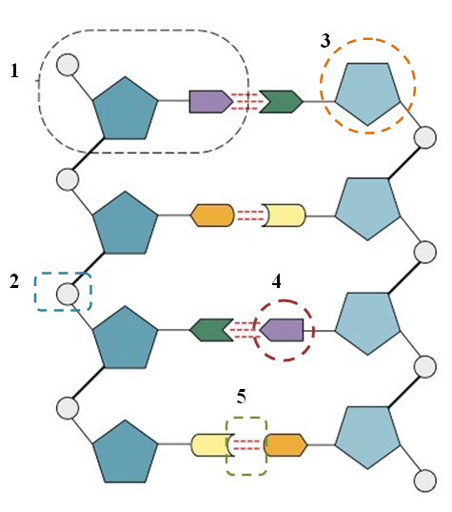

- Match the selected fragments and their names:
- Sugar
- Hydrogen bonds
- Nucleotide
- Nitrogenous base
- Phosphate group

- Select missing words from the list below.

A single strand of DNA is a polymer of _____1______ joined _____2______ between the _____3______ of one and the _____4______ of the next to form a “backbone” from which the ____5_______ bases stick out. In its natural state, DNA has _____6______ wound around each other in a _____7______ . The bases on each strand are bonded to each other with ______8_____ bonds. Only specific bases bond with each other; ______9_____ bonds with _____10______ , and _____11______ bonds with ____12_____ .

- adenine
- double helix
- covalently
- cytosine
- deoxyribose sugar
- guanine
- hydrogen
- nitrogenous bases
- nucleic acids
- phosphate group
- thymine
- two strands

- You have been presented with an image of two nitrogenous bases found in the DNA molecule. It is the base-pairing correct? What bases are shown in the picture? Is it a fragment of a DNA or RNA molecule?
