LESSON number 3
NUCLEUS, ITS STRUCTURAL COMPONENTS. REPRODUCTION OF CELLS
Purpose: To study the role of the nucleus as a leading component of the cell, the peculiarities of its organization in connection with the functions performed. To acquire and consolidate knowledge about the structure of the cell nucleus, the cell cycle, as well as the methods and mechanisms of cell self-reproduction, which are the basic material for understanding many processes in biology and medicine, both in health and in pathology.
Describe kernel functions

Sign the structural components of the kernel in the figure
3
4
5
6
7
8
9
1
2
1.
2.
3.
4.
5.
6.
7.
8.
9.

MODEL OF THE STAGES OF COMPACTING THE GENETIC MATERIAL
(draw a sketch of the stages, indicating their features)

1.
2.
3.
4.
5.
6.
7.

STRUCTURE OF THE CHROMOSOME

1.
2.
3.
4.
5.
6.
7.
8.

CHROMOSOME TYPES

Metacentric- |  | Submetacentric |  | Acrocentric |  | Telocentric

CLASSIFICATION OF HUMAN CHROMOSOME BY SIZE AND LOCATION OF THE CENTROMER
Group | № chromosome pair | Characteristics of a group of chromosomes
A
B
C
D
E
F
G
Sexual chromosomes

CELL CYCLE
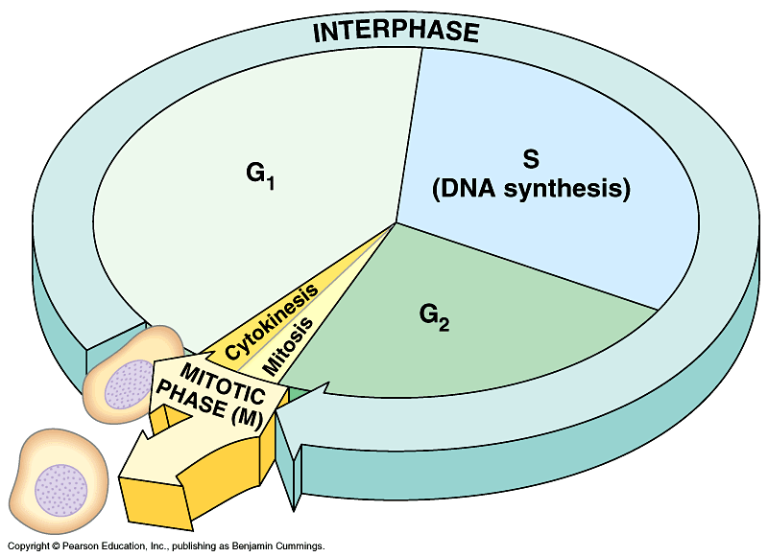
5
2
3
4
1
7
6
1.
2.
3.
4.
5.
6.
7.

Interphase
G1
S
G2
Mitosis
Cytokinesis
Kariokinez

MITOSIS IN ANIMAL CELL

1
2
3
4
5
1.___________________
2.___________________
3.___________________
4.___________________
5.___________________

АМИТОЗ В КЛЕТКАХ МОЧЕВОГО ПУЗЫРЯ МЫШИ

MITOSIS differences
Plant cell |  | Animal cell
Kariokinez
Cytokinesis
PRACTICAL PART
Work No. 1
Interphase nuclei and metaphase plates in the culture of human peripheral blood lymphocytes

1. | Metaphase chromosomes
2. | Interphase nucleus

Work number 2
Polytene chromosomes of Drosophila and Chironomus

______________________________

_______________________________

Work number 3
Mitosis in onion root cells

Find and determine the phases of mitosis in the division zone at the apex of the onion root.

Prophase |  | Metaphase |  | Anaphase |  | Telophase

Work No. 4
Mitosis in the marginal zone of the liver.
Увеличение ___×___

1.
2.
3.
4.
5.

Conduct a comparative analysis (in the table below) the process of mitosis observed on permanent microslides in cells a) the division zone of the onion root and b) in the marginal zone of the liver

№ п/п | Compared indicators | Onion root dividing area | The marginal zone of the liver
1.
2.
3.
4.
5.

Work number 5
Amitosis in mouse bladder cells.

Увеличение ___×___

1.
2.
3.

Specify the difference between this method of cell division - amitosis or "direct cell division". What are its advantages and disadvantages? What fabrics is it typical for?

