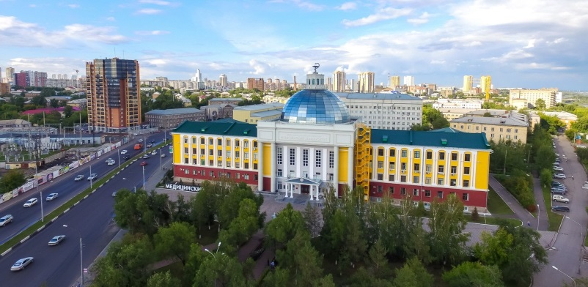
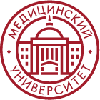
Krasnoyarsk State
Medical University

Programs in English language

Documents to prepare for admission
Admission procedure starts in June. But you already can make some steps to become a KrasSMU medical student. The most important step is to prepare documents.
So, what exactly will you need?

1) Notarized translation of the first two pages of the passport into Russian language. Validity period of the passport must be 2 years from the present moment. – You can do it with any available notary in your country

2) documents of education with indication of the received qualification (degree), studied subjects and marks received in them* (school/university/college leaving certificate/diploma, etc.) with notarized translation into the Russian language – You can do it with any available notary in your country

3) Certificate of recognition of the foreign education – You should apply to your local Embassy for this

4) A document confirming Russian language knowledge (if any)

5) If the applicant has been to Russia before (on language courses/summer schools/preparatory courses), a certificate or any other document confirming this activity (if any)
INTERNATIONAL@KRASGMU.RU | KRASSMU_INTERNATIONAL | +79235702585 | KRASGMU.RU

