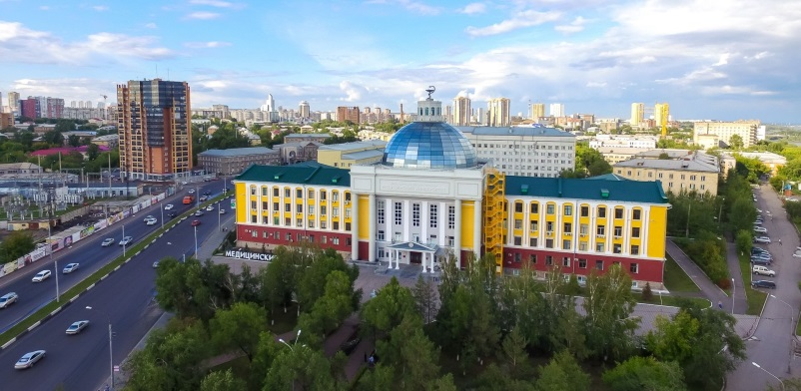
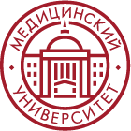
Krasnoyarsk State
Medical University

Programs in English language

Admission schedule & deadlines
Step 1. Application
13.06.2022-19.09.2022

Student fills in the application and sends documents to the University
- Register at the webite https://abit.krasgmu.ru/
- Fill in all the forms in your account
- Follow the instructions that you see
- In case you have any problems, please contact us international@krasgmu.ru

Step 2. Entrance exams online
20.09.2022-24.09.2022

Student receives information about the entrance exams (link, day, time) by the e-mail.
Entrance exams in Biology, and Chemistry

Step 3. Enrollment
25.09.2022-28.09.2022
Lists of the students who succeeded at the entrance exams are posted on the website.
Students check the lists and send their agreements to enrollment.
Enrollment order is issued by the University and posted on the KrasSMU website.

INTERNATIONAL@KRASGMU.RU | KRASSMU_INTERNATIONAL | +79235702585 | KRASGMU.RU

