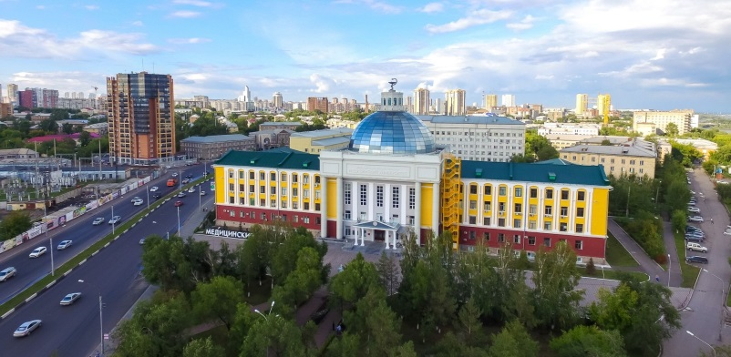
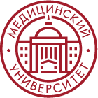
Krasnoyarsk State
Medical University

Programs in English language

Information | Preparatory Department
KrasSMU is the leading university in Siberia in training high-qualified medical professionals.  Students from all over the world (Egypt, Nigeria, Iran, Syria, Mongolia, Latin America, etc.) choose our English language programs.  Exotic Siberian climate, beautiful mountainous nature of our region, friendly Russian people, relatively low cost of education are key factors that attract foreign students to KrasSMU.  Professors at KrasSMU are qualified medical experts and top-level doctors of Krasnoyarsk region. They are all trained in English language to provide you with high quality medical education. | WHAT WILL YOU STUDY?  •Russian language intensive course (from 0 to B1)  •Biology, Chemistry, Physics – only useful knowledge that will help you successfully pass entrance exams to any medical university in Russia  •In the end of the course all students receive academic certificates  WHERE WILL YOU LIVE?  •Students live at the University dormitory. 2-minute walk from the main building, 5-minute drive from the center of the city.  •Cost of living in the dormitory – about 1500 rubles per month  WHAT IS THE COST?  •130000 rubles/8 months, from December to July  •Airplane tickets and food are not included  HOW TO APPLY?  You should send us (preparatory@krasgmu.ru) the following documents:  •Application: https://krasgmu.ru/index.php?page[common]=dept&id=2491&cat=folder&fid=58812  •Passport translated into the Russian language (notarized translation)  •School-leaving certificate (or any other document confirming your level of education) translated into the Russian language, notarized translation  After that, we will contact you for concluding the Contract. Student is considered to be enrolled only after the full payment of the course.  WHAT’S NEXT?  The University starts doing the invitation for entrance into the Russian Federation. When the invitation is ready, the student receives it by e-mail and takes it to the local Russian embassy to get a visa.  When student receives visa, he/she buy tickets and then can come to Russia to follow dreams and study!
PREPARATORY@KRASGMU.RU | KRASSMU_INTERNATIONAL | +79235702585 | KRASGMU.RU
