Lesson 2
The psychodynamic approach
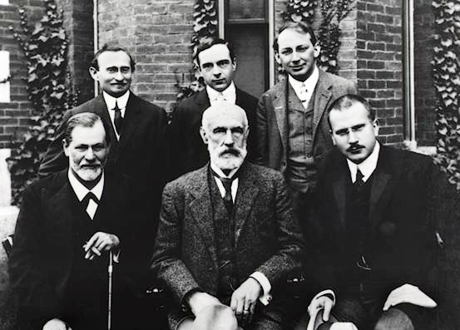
1. Answer the questions.
● What do you know about psychoanalysis?
● Will you name the most famous psychoanalysts?
● Who was the father of psychoanalysis?

2. Reading Task:
Define whether these statements:
1. Freud was a Viennese physician who made a significant impact on mental health.
1) в тексте нет информации
2) истинным
3) ложным
2. Freud studied patients who exhibited various behavioural problems, except hysteria.
1) в тексте нет информации
2) ложным
3) истинным
3. The patient had no observable organic cause.
1) в тексте нет информации
2) ложным
3) истинным
4. Anna Freud helped her father in the research work.
1) ложным
2) в тексте нет информации
3) истинным

The name, for better or worse, most closely associated with psychology is Sigmund Freud although, accurately, he should be most closely associated with psychoanalysis, a different beast altogether. Freud was a Viennese physician who, despite an early research career focusing on the neurobiological basis of mental disorder, made a significant impact on mental health and personality by studying patients who exhibited various behavioural problems, especially hysteria (where people feel paralysis of some part of the body despite there being no physiological basis for the condition).
One patient, in particular, provided the foundations for the entire Freudian theoretical edifice. Anna O. was seen by Freud and a fellow physician, Josef Breuer. She suffered from typical hysteria – loss of speech, limb paralysis, and so on, with no discernible organic cause. Under hypnosis it was discovered that the symptoms dated back to when she felt unable to express an emotion. When she experienced this emotion under hypnosis, the hysteria subsided (representing a catharsis). However, it was later discovered that she did not fully recover and took morphine for her symptoms, a fact of which Freud was apparently aware.
The case of Anna O. and others convinced Freud that human behaviour was motivated by instinctual drives (which could be triggered by traumatic events) that supplied ‘psychic energy’. If this energy could not be discharged, behavioural disturbances followed. Traumatic events lead to the hiding of strong emotions, and the events and the emotions that generated the trauma are found in the unconscious. The unconscious exerts control over our observable behaviour. Unconscious traumatic events can also be prevented from reaching consciousness (a process called repression).
3. Vocabulary Exercises
1. Find the synonyms to the following words using the text.
Exactly, considerably, supply, visible, decrease, persuade, relieved, abnormality.
2. Match the verb (1- 6) with prepositions (a –f).
1. associate a. from
2. focus b. from
3. made an impact c. for
4. provide d. on
5. suffer e. with
6. prevent f. on
Follow –Up Activities
Explain how the unconscious exerts control over our observable behaviour.
Clinical psychologists use psychological intervention in their practice. What is the aim of it?

Martin G.N. Psychology. A Beginner’s Guide. Oneworld Publications. Oxford (England). 2008. P. 129-130.

